MORAZHA CO-OPERATIVE ARTS AND
SCIENCE COLLEGE
(Affiliated to Kannur University)

P.O.Morazha, Kannur Dt., PIN-670331



A Project Report On
EXAMINA

Submitted in partial fulfilment of requirement for the award of the degree of

BACHELOR OF COMPUTER APPLICATIONS

Of

KANNUR UNIVERSITY

By

ANAMIKA PRADEEP : MO22BCAR38

MORAZHA CO-OPERATIVE ARTS AND
SCIENCE COLLEGE
(Affiliated to Kannur University)

P.O.Morazha, Kannur Dt., PIN-670331



CERTIFICATE

This is to certify that the project entitled “EXAMINA” submitted in partial fulfilment of the requirement for the award of the degree of BACHELOR OF COMPUTER APPLICATIONS is a result of bonafide work carried out by ANAMIKA PRADEEP during the academic year 2024- 2025

Internal Guide:

Head of the Department:

Principal:

External Examiners:

- 2.

MORAZHA CO-OPERATIVE ARTS AND
SCIENCE COLLEGE
(Affiliated to Kannur University)

P.O.Morazha, Kannur Dt., PIN-670331



DECLARATION

We hereby declare that the project entitled “EXAMINA” submitted for the BCA Degree is our original work and the project is not used for the award of any degree, associate ship, fellowship or any other similar titles.

Signature of the student:

Place:

Date:

ACKNOWLEDGEMENT
With immense gratitude and respect, we would like to extend our heartfelt thanks to everyone involved, directly or indirectly, in the preparation and success of this project. It has been both a pleasant and highly educational experience.
We offer our sincere thanks to Mr. Shajin T, the project manager of Integos Intelligent Solution, for his invaluable support and constant interaction with us. We owe much of our success to our project guide, Ms. Nithya KV, whose tremendous support and guidance played a critical role in this project's success.
We would also like to thank the management and staff members of Integos Intelligent Solution for their assistance throughout the project analysis phase. Our heartfelt gratitude goes out to all individuals who made this project possible.
We express our profound appreciation to our beloved principal, Prof. Dr. P. P. Jayakumar, and Ms. Remya R, head of the computer department, for their enthusiastic attention and timely help in completing our project.
A special acknowledgment is extended to our guide, Mr. Shijil K V, for his patience and valuable suggestions, which greatly contributed to our understanding and preparation of the project report. We also thank Mrs. Remya R, Mr. Shijil K V, and Mr. Abdul Vahab for their technical comments and guidance throughout the project.
Lastly, we express our deep gratitude to our parents, family members, friends, and everyone who provided encouragement, constructive criticism, and unwavering support, which made this seminar a satisfying and fulfilling experience.

ABSTRACT

Examina is an online system that makes managing exams easy. It allows students to take tests from anywhere with internet access. The platform handles everything—registering for exams, conducting them smoothly, grading automatically, and giving instant feedback.
Security features ensure fair exams. A leaderboard encourages students to do their best by adding a friendly competition element.
For teachers, Examina makes it easy to create and schedule exams using simple tools. The system grades exams automatically and provides detailed reports, helping teachers improve their teaching methods.
School principals and administrators benefit from centralized exam management, automated record-keeping, and better communication. It simplifies scheduling, approvals, and keeps data safe.
Overall, Examina makes exams more efficient, secure, and accessible for everyone. The website will be updated regularly to provide the latest information.

CONTENTS

CONTENT  NO. | PAGE  NO. | TOPIC
1 | 1 | INTRODUCTION
 |  | PURPOSE OF THE PROJECT
 |  | SCOPE OF THE PROJECT
2 | 3 | SYSTEM STUDY AND ANALYSIS
 |  | METHODOLOGY
 |  | EXISTING SYSTEM
 |  | PROPOSED SYSTEM
3 | 4 | FEASIBILITY STUDY
 |  | TECHNICAL FEASIBILITY
 |  | BEHAVIORAL FEASIBILITY
 |  | ECONOMIC FEASIBILITY
 |  | OPERATIONAL FEASIBILITY
4 | 6 | SOFTWARE REQUIREMENT ANALYSIS
 |  | SYSTEM REQUIREMENTS
5 | 9 | MODULE DESCRIPTION
 |  | ADMIN
 |  | COMMON
 |  | PRINCIPAL
 |  |  | TEACHER
 |  |  | STUDENT
6 | 11 |  | TECHNOLOGY SPECIFICATIONS
 |  |  | JAVASCRIPT
 |  |  | CSS
 |  |  | MYSQL
 |  |  | PYTHON-DJANGO
7 | 13 |  | SYSTEM DESIGN AND DEVELOPMENT
 |  |  | SYSTEM DESIGN
 |  |  | INPUT DESIGN
 |  |  | OUTPUT DESIGN
 |  |  | LOGICAL DESIGN
 |  |  | DATABASE DESIGN
8 | 17 |  | SYSTEM DESIGN
 |  |  | DATA FLOW DIAGRAM
 |  |  | ENTITY RELATIONSHIP DIAGRAM
 |  |  | USE CASE DIAGRAM
9 | 32 |  | DATABASE DESIGN
 |  |  | NORMALIZATION TECHNIQUES
 |  |  | TABLE DESIGN
10 | 41 |  | SYSTEM TESTING
 |  |  | TEST TYPES
 |  |  | TESTING METHODS
11 | 44 |  | IMPLEMENTATION
 |  |  | IMPLEMENTATION PROCEDURES
12 | 45 |  | SYSTEM MAINTENANCE
 |  |  | CORRECTIVE MAINTENANCE
 |  |  | ADAPTIVE MAINTENANCE
 |  |  | PERFECTIVE MAINTENANCE
 |  |  | PREVENTIVE MAINTENANCE
13 | 46 |  | FUTURE ENHANCEMENT
14 | 46 |  | CONCLUSION
15 | 47 |  | BIBILOGRAPHY
16 | 48 |  | APPENDIX

1. INTRODUCTION
Examina is an innovative online examination management system designed to revolutionize the process of administering, taking, and managing exams over the internet. This comprehensive digital platform caters to the needs of educational institutions and organizations by providing a secure, user-friendly environment for examinations. Examina offers unparalleled convenience for students, allowing them to take exams from any location with internet access. It streamlines the entire examination process, from easy registration and seamless exam conduction to automated grading, significantly reducing the time and effort required. With enhanced security measures, Examina ensures fair testing and maintains the integrity of the examination process. One of the key features of Examina is its competitive leaderboard, which motivates students to perform their best and fosters a healthy competitive spirit. The platform also provides instant feedback, enabling students to quickly understand their strengths and areas for improvement, thereby refining their learning strategies. For teachers, Examina simplifies exam creation and scheduling with its user-friendly tools. Educators can design customized assessments that align with their specific learning objectives, and the automated grading system minimizes manual effort, providing immediate results and saving valuable time. Detailed performance analytics offer insights into student progress, helping teachers adjust their teaching strategies to better meet the needs of their students. Additionally, Examina reduces paperwork and streamlines communication, making the assessment process more efficient and organized. Examina benefits principals and administrators by centralizing exam management. The platform automates record-keeping, generating detailed performance reports that provide comprehensive insights into overall student performance and institutional efficiency. This centralized approach enhances efficiency with streamlined scheduling and approval processes, secures sensitive data, and improves communication between stakeholders. These features empower principals and administrators to oversee exams effectively, make informed decisions, and boost overall institutional efficiency. Overall, Examina transforms the examination landscape by making assessments more efficient, secure, and accessible for all stakeholders involved. It enhances the learning

experience for students, simplifies the assessment process for teachers, and provides valuable tools for administrators to manage and improve institutional performance

SCOPE AND PURPOSE OF THE PROJECT
The Examina project creates an online exam management system for secure exam administration, automated grading, customizable assessments, and improved communication.

2. SYSTEM STUDY AND ANALYSIS

METHODOLOGY
Incremental model is used as the methodology. Incremental model is an evolution of the waterfall model. The product is designed, implemented, integrated and tested as a series incremental build. When an incremental model is used, the first increment is often a core product. The core product undergoes a detailed review. As a result of use and/or evaluation of a plan is developed for the next increment. The plan addresses the modification to the core product to better meet the needs and delivery of additional features and functionality. Software is constructed in a step-by-step manner. While a software product is being developed, each step adds to what has already been completed. Following are the activities that have been carried out to develop each incremental product.

PROPOSED SYSTEM
Examina is an online exam management system designed to make testing easier, fairer, and more efficient. It allows students to take exams from anywhere while ensuring security and instant feedback. Teachers can create and schedule exams easily, with automated grading to save time. Administrators benefit from centralized exam management, automated record-keeping, and improved communication

3. FEASIBILITY STUDY
A feasibility study is a preliminary study undertaken to determine and document projects viability. Results of this study are used to make a decision whether to proceed with the project, or not. If it indeed leads to a project being approved, it will-be-before the real work of the problem and the recommendation on the best alternative. The feasibility study was carried out to find whether the proposed system can be developed and implemented without any problem within the time limit. The following feasibility was considered for the project in order to ensure that the project is viable and it does not have any major obstructions. In this regard the following feasibility analysis was conducted.
· Technical Feasibility
· Behavioural Feasibility
· Economic Feasibility
· Operational Feasibility

TECHNICAL FEASIBILITY
The various schedules were assigned keeping in mind the cost and performance of the system. The hardware requirements were taken into consideration so that the system runs on the proper platform. So, it fulfills the technical feasibility. So, our project can run any operating system like Windows, Ubuntu etc.
So, it is technically feasible.

BEHAVIORAL FEASIBILITY

When doing projects in an external firm there can be cooperation and other unpredictable egoism from the colleagues especially when a new idea is being introduced. These are behavioural and depend upon the individual behaviour of the person involved. Behavioral feasibility was done in order to analyse the attitude of the people who are directly involved with my project.

ECONOMIC FEASIBILITY
The proposed system is cost effective because of its user-friendly interface. The administrator can directly view and make updates on the records.

OPERATIONAL FEASIBILITY
The proposed project is said to be beneficial only if they can be modules and carved out into a system that will meet all the requirements. The best for the feasibility prohibits if the system would run without faults when it is deployed or there are any major hurdles to be the implementations of the proposed system. The proposed system is not supposed to cause any harm to the user or the computer that is being used and the system is safe and secure.

4. SOFTWARE REQUIREMENT ANALYSIS

This process is also known as a feasibility study. The need for this software was investigated. A Software Requirement Specification document was created at the end of this step. It holds all information required to develop the project which includes functional and non-functional requirements. The requirement’s gathering process is intensified and focused especially on software. The information domain for the software, as well as required function, behaviour, performance and interfacing are well understood.

SYSTEM ANALYSIS AND DESIGN
In this phase, the software development process, the software’s overall structure is defined. The logical system of the product is developed in this phase. A dataflow diagram which indicates the flow of data through the system is created. This phase produces a high-level design and a low-level design. The high-level design comprises the modules to be generated and their purpose. The low-level design consists of a more elaborated view of the modules which includes the method to be defined.

CODE GENERATION
The design created in the design phase must be translated into a machine-readable form. The code generation step performs this task. Since this project involves connection to databases, the language has been chosen as Python Django. Front end is created with HTML and DB SQLite is used for storing data.

TESTING
After the code was generated, the software program testing begins. An error in the program flow was identified in this step.

SYSTEM REQUIREMENTS

Software Requirements:

Front end : HTML, CSS, JavaScript, Bootstrap
Language : Python Django
Back end : MySQL
Operating system : windows 7 or above
IDE : Visual code

HARDWARE REQUIREMENTS

Server Side

Processor : Intel Pentium Core i3 and above
Primary Memory : 4GB RAM and above
Storage : 320 GB hard disk and above
Display : VGA Color Monitor
Key Board : Windows compatible
Mouse : Windows compatible

Client Side

Web Server : Xampp
Platform : Web

5. MODULE DESCRIPTION
There are three types of users that interact with the system:
ADMIN
- Admin have a username and password to login into the system.
- Admin have control over the whole system.
- Admin have a username and password for login into the system.
- Admin can know about malpractices.
- Admin can view registered institutes and edit their details.
- Admin can view, add & remove institutes.
- Admin can approve or deny requests of institution.

PRINCIPAL
- Principal have a username and password to login into the system which is approved by the admin.
- Principal can view their profile
- Principal can approve teachers.
- Principal can view the registered teacher and edit their details.
- Principal can monitor the leaderboard.
- Principal can monitor the teacher's activity.
- Principal generates reports.
- Principal sets, modifies and manages exam date and time for different classes.
STUDENTS
- Student accounts are created by themselves.
- Students have username and password to login into the system.
- Students can view their profile.
- Students can manage and update personal information.
- Students can submit their assignment and check their status.
- Students can view their results for completed exams.
- Students can track academic performance over time, and overall progress.
- Students have their own dashboard where they can access resources provided by faculties

TEACHERS
- teachers can login to their account
- teachers can approve students
- teachers creates exams
- teachers schedules exams
- teachers can obtain results of exams by automated grading of MCQ exams
- teachers can manually correct descriptive exams
- teachers can view the leader board
- teachers can provide resources for students

COMMON
- this module helps institutions to register and apply for account creation to admin

6. TECHNOLOGY SPECIFICATIONS

This web application follows a client-server model, where the client-side is developed using HTML (Hypertext Markup Language) for structuring web pages. The server-side scripting is handled by Python using the Django framework, which simplifies backend development. The application runs on a web server and uses SQLite as the database system for efficient data storage and management.

Python Django
Python is a versatile programming language used for web development, and Django is its high-level framework that simplifies backend development. Django provides built-in tools for security, database management, and scalability, making web applications efficient and robust. It enables features like real-time updates, user authentication, and data processing. Just as JavaScript enhances frontend interactivity, Django powers the backend, working alongside HTML (structure) and CSS (styling) to build modern, dynamic web applications.

CSS
Cascading Style Sheet (CSS) is a style sheet language used to describe the presentation of a document written in HTML or XML. CSS describes how elements should be rendered on screen, on paper, in speech or on other media.

SQLite
SQLite is a lightweight, open-source relational database management system (RDBMS) that uses SQL for efficient data processing. Unlike traditional databases, it is serverless, meaning it does not require a separate database server, making it ideal for small to medium-scale applications. SQLite is widely used in web applications, mobile apps, and embedded systems due to its simplicity and portability.

HTML (Hypertext Markup Language)
HTML is the standard markup language used to create and structure web pages. It defines the elements of a webpage, such as headings, paragraphs, images, links, and tables. HTML works alongside CSS (for styling) and JavaScript (for interactivity) to build modern websites.

7. SYSTEM DESIGN AND DEVELOPMENT

System design is the process of defining the components, modules, interfaces and data for a system to satisfy specified requirements. System development is the process of creating or altering systems, along with the processes, practices, models, and methodologies used to develop them.

SYSTEM DESIGN
System design is the process or art of defining the architecture, components, modules, interfaces, and data for a system to satisfy specified requirements. System design involves designing a new system or computer application that will meet the requirements identified during system analysis. System depending designing is concerned with the computer-oriented design of the system-details of the input transactions, the details of the printed reports, screens and other outputs, database structure, the contents of records, the processing required and the efficiency of the system from a computer processing point of view. In general, the following design objectives must be kept in mind:
· Practicality of the System
· Efficiency of the System
· Minimized cost of the system
· Flexibility of the System
· Security of the System
The system design process is to achieve objectives like practicability, efficiency, minimized cost, flexibility, and security of the system. It involves, first, logical design and then, physical construction of the system. The logical design specifies the structure and characteristics of output, input, files, database and procedures. The physical design involves the construction of actual program files and a working system.

INPUT DESIGN
Input design plays a vital role in the life cycle of software development. It repairs the very careful attention of the developers. It specifies the manner in which the data enters the system for processing.
Input design can ensure the reliability of the system and the producer’s results from the accurate data or it may result in the output of an enormous amount of data. According to the software engineering concepts, the input forms of screens are designed to provide validation control over the input limit. This system has input screens in almost all the modules. Error messages have been developed to alert the user whenever he commits some mistakes and guides him in the right way. Input design determines whether the user interacts with the system efficiently. It consists of developing specifications and procedures for the data preparations. So, structured steps are necessary to put the transaction data into usable form for processing. Input design is the process of converting the user-originated inputs to a computer-based format. It also includes the method of input and entry into the system.
There can be many factors that can be taken into account
· Flexibility of format
· Speed
· Accuracy
· Type of input
· Verification methods
· Offline contact facility
· Automatic features
· Ease of use
Keyboard is the most commonly used input media. In accuracy, input data is the most common cause of errors in data processing. Errors entered by the user can be controlled by the input design. The design for handling input specifies how the data are accepted for computer processing. Input design is a part of the overall system design that needs careful attention and it includes specifying the means by which actions are taken. A system user interacting through a workstation must be able to tell the system whether to accept input, produce a report or end the processing. The collection of the input data is considered to be the most extensive part of the system design. Since the inputs have to be planned in such a manner so as to get the relevant information, extreme care has to be taken to obtain the information. If the data going into the system is incorrect, then the processing and the outputs will magnify these errors.

OUTPUT DESIGN
Often the most important feature of the information system for users is the output it produces. Without quality outputs, we may even fill the entire system is so unnecessary that they avoid using it and that possibly causes the system to fail. Output design refers to the generation of the results and information of the project. It should be an organized and well out manner. It involves conceiving, planning out and specifying the external observable characteristics of the product. It includes user displays and the report formats. The normal procedure is to design the outputs in detail first and then to work back with the inputs. The outputs can be in the form of the operational documents and report. The input records have to be validated, edited, organized and accepted by the system before being processed to produce the output. Output is the most important and direct source of information to the users. Designing the computer output should be produced in an organized manner. The right output must be developed while ensuring that each output element is designed so that people will find the system easy for use or user friendly. The output design has to be done so that the results of the processing should be communicated to the user. Effective output design will improve the clarity and performance of the outputs. Output is the main reason for developing the system and the basis on which the usefulness of the application will be evaluated. Output design phase of the system is concerned with the convergence of the information to the end user in a user-friendly manner. The output design should be efficient, intelligible so that the system relationship with the end user improves and thereby enhancing the process of the decision making.

LOGICAL DESIGN
A logical design is a conceptual, abstract design. You do not deal with the physical implementation details yet; you deal only with defining the types of information that you need. The process of logical design involves arranging data into a series of logical relationships called entities and attributes.

DATABASE DESIGN
The database design is a logical development in the methods used by the computer to access and manipulate data stored in the various parts of the computer system. Database is defined as an integrated collection of data. The overall objective in the development of database technology has been to treat data as organization resources and as an integrated while. The main objectives of the database are data integration, data integrity and data independence. Database management system (DBMS) allows the data to be protected and organized separately from other resources like hardware, software and programs. DBMS is a software package, which contains components that are not found in other data management packages. The significance of DBMS is the separation of data as seen by the programs and data as stored on the direct access storage devices. That is the difference between logical and physical data. Database design is the first step of the three design activities that are conducted during the software engineering process. The impact of data structure on program structure and procedural complexity causes data design to have a profound influence on software quality. The concepts of shared memory and semaphores provide the foundation for an approach to data design. The database is structured in fixed format records of several types. Each record type defines a fixed number of fields or attributes and each field is usually of a fixed length. Usually, centralized data management software is called RDBMS.

8. SYSTEM DESIGN

DATA FLOW DIAGRAM
Data Flow Diagrams (DFD) is the most commonly used way of documenting the processing of the required system. They are the pictorial way of showing the flow of data into, around and out of the system. They can be understood by the users and are less prone to misinterpretation than textual description. A complete set of DFDs provide a compact top-down representation of the system, which makes it easier for users and analysts to envisage the system as a whole. DFD also known as Bubble Chart has the purpose of clarifying system requirements and identifying major transformations that will become programs in system design. So, it is the starting point of the design phase that functionally decomposes the requirements specifications down to the level of details. It does not show the information about the timing processes or information about whether processes will operate in sequence or in parallel. A DFD shows what kind of data will be put into and out of the system, where data will come from and go to and where data will be stored. A DFD is often a preliminary way of creating the overview of the system. DFDs mainly use the following symbols:
Circles are used to represent processes. Processes represent activities in which data is manipulated by being stored or retrieved or transferred in some way.

Rectangles are used to represent external entities, which are the sources of data that enter the system or the recipients of data that leave the system.

Open rectangle are used for representing data stores or databases.

Arrows are used to represent the data flow. Data flows represent the movement of data between other.

DATA FLOW DIAGRAM

LEVEL 0

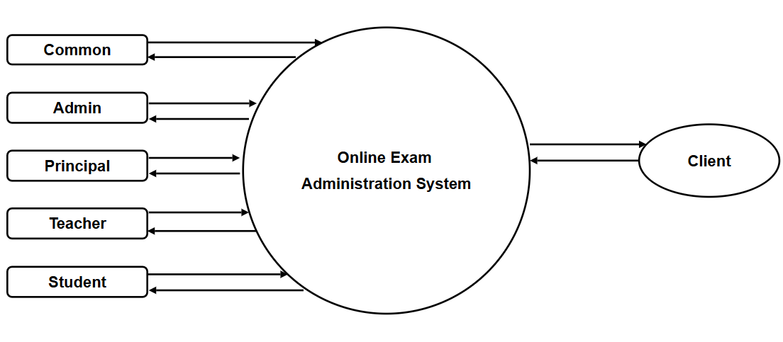

LEVEL 1

FOR COMMON

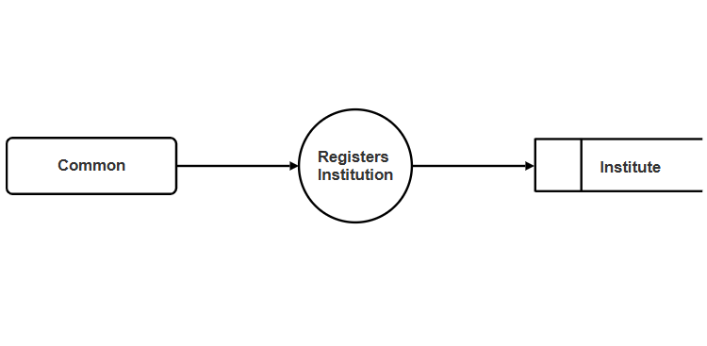

LEVEL 1

FOR ADMIN

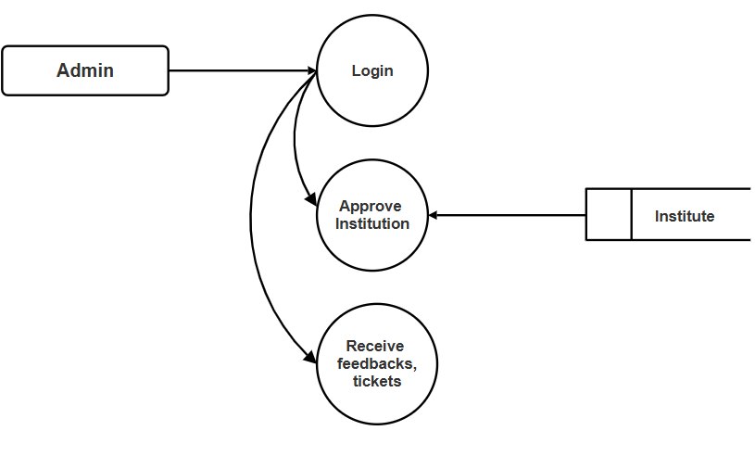

LEVEL 1

FOR PRINCIPAL

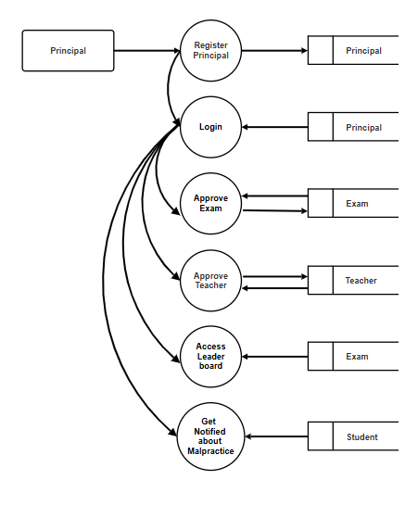

LEVEL 1

FOR TEACHER

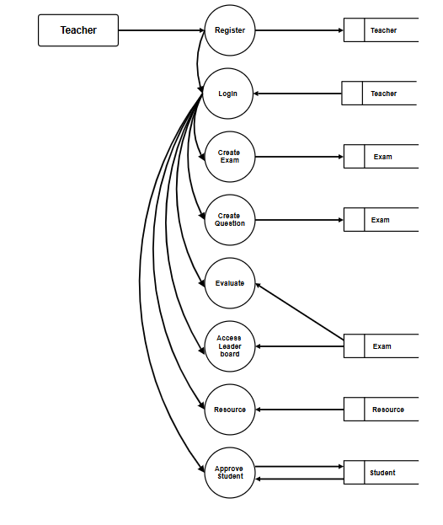

LEVEL 1

FOR STUDENT

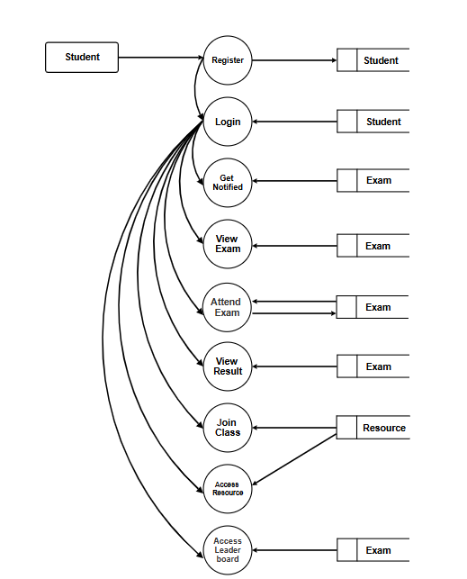

ENTITY RELATIONSHIP MODEL
An Entity Relation of (ER) Diagram is a specialized graphics that illustrates the interrelationship between entities in a database. ER diagrams often use symbols to represent 3different types of information. Boxes are commonly used to represent entities. Diamonds are normally used to represent relationships and ovals are used to represent attributes. An entity Relationship model (ERM), in software engineering is an abstract and conceptual represent of data. Entity Relationship modelling is a relational schema database modelling method, used to produce a type of conceptual schema or semantic data model of a system, often a relation database, and its requirements in a top-down fashion.

ENTITY:
Entity is the thing which we want to store information. It is an elementary basic building block of storing information about business process. An entity represents an object defined within the information system about which you want to store information. Entities are distinct things in the enterprise.

RELATIONSHIP:

A relationship is a named collection or association between entities or used to relate two or more entities with some common attributes or meaningful interactions between the objects.

ATTRIBUTES:

Attributes are the properties of the entities and relationship, Descriptor of the entity. Attributes are elementary pieces of information attached to an entity.
ER DIAGRAM
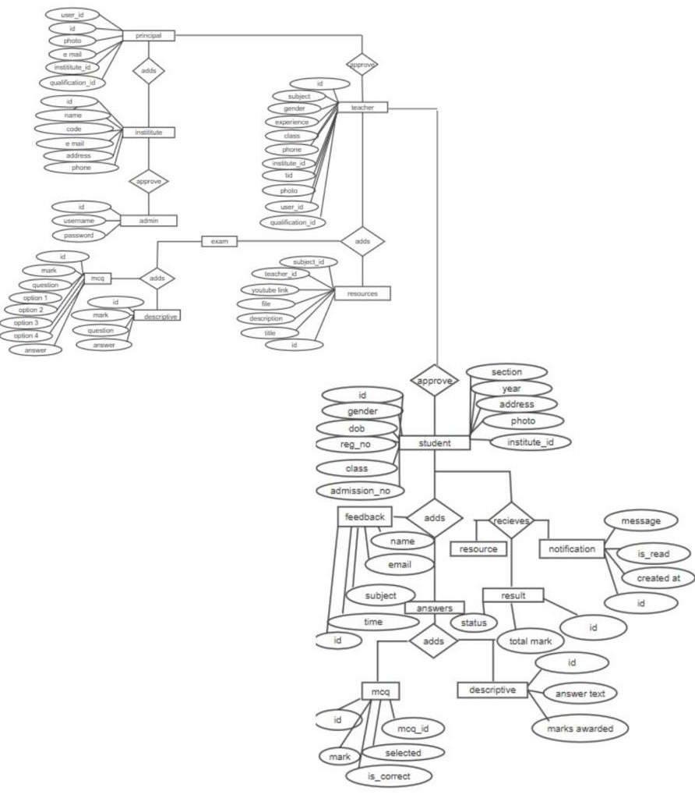
USE CASE DIAGRAM

A use case diagram at its simplest is a representation of a user's interaction with the system that shows the relationship between the user and the different use cases in which the user is involved. A use case diagram can identify the different types of users of a system and the different use cases and will often be accompanied by other types of diagrams as well. The use cases are represented by either circles or ellipses. While a use case itself might drill into a lot of detail about every possibility, a use-case diagram can help provide a higher-level view of the system. It has been said before that "Use case diagrams are the blueprints for your system". They provide the simplified and graphical representation of what the system must actually do. Due to their simplistic nature, use case diagrams can be a good communication tool for stakeholders. The drawings attempt to mimic the real world and provide a view for the stakeholder to understand how the system is going to be designed. The purpose of the use case diagrams is simply to provide the high-level view of the system and convey the requirements in laypeople's terms for the stakeholders. Additional diagrams and documentation can be used to provide a complete functional and technical view of the system.

USE CASE DIAGRAM

COMMON

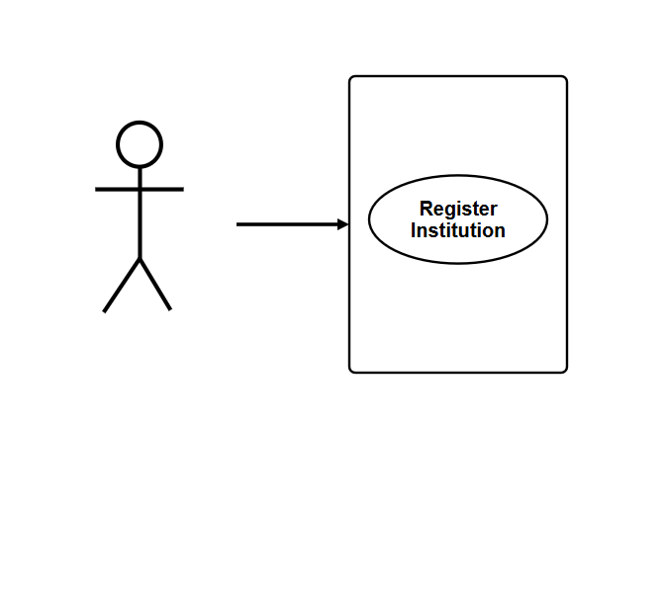

ADMIN

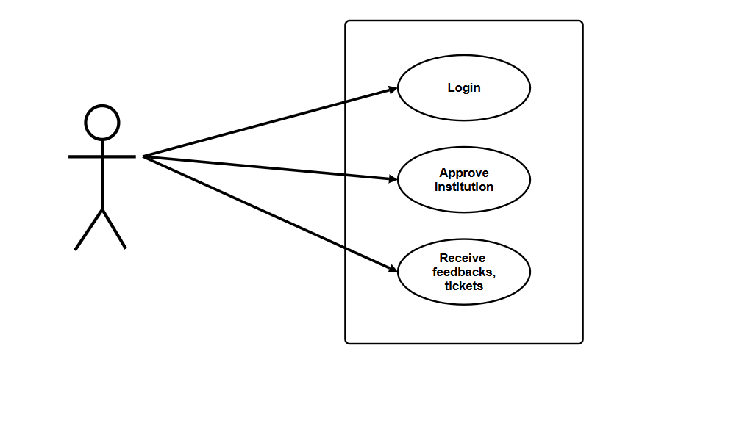

PRINCIPAL

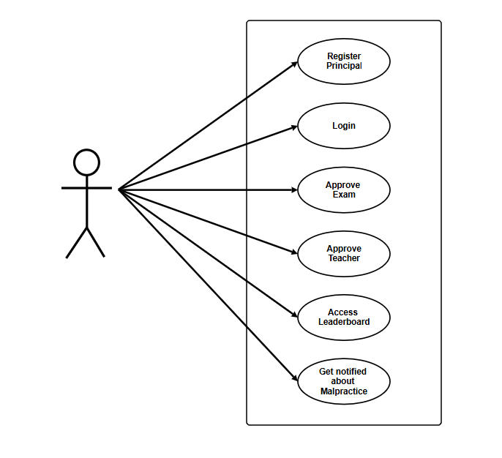

TEACHER

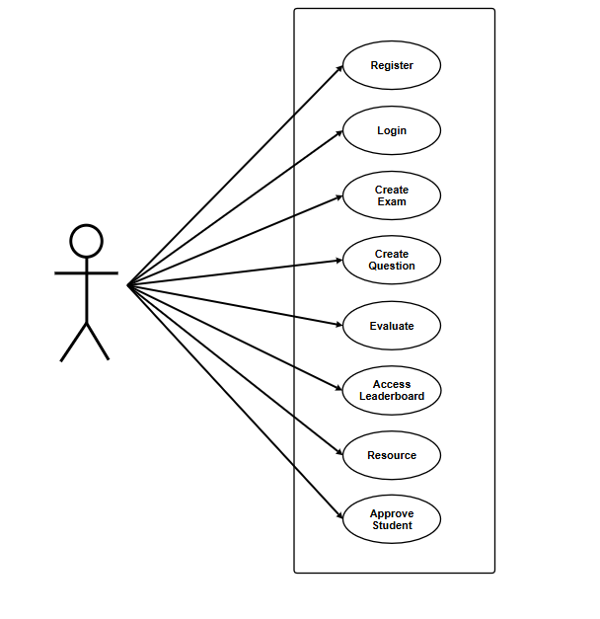

STUDENT

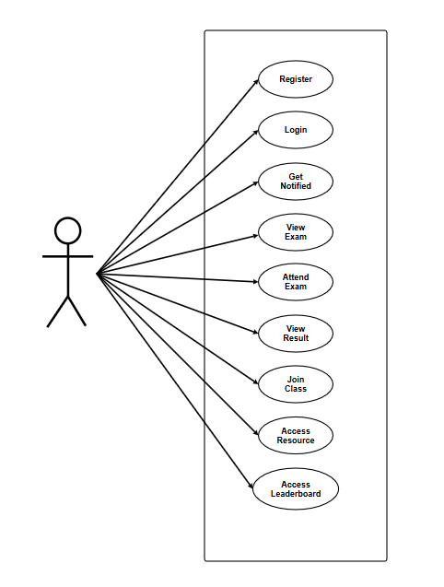
9. DATABASE DESIGN

Database design is an important place in designing a system. During this phase care should be taken to avoid redundancy of information storing into a database, since it leads to wastage of memory space.

NORMALIZATION TECHNIQUES:
Normalization is a process of simplifying the relationship between data elements in a record. Through normalization a collection of data in a records structure is replaced by successive record structures that are simpler and more predictable and therefore more manageable.

First Normal Form
A relation is said to be in first normal form if the values in the relation are atomic for every attribute in the relation. By this we mean simply that no attribute value can be a set of values or as it sometimes expressed, a repeating group.

Second Normal Form
A relation is said to be in second normal form if it is in first normal form and it should satisfy any one of the following rules. Primary key is a not a composite primary key No non-key attribute is fully functionally dependent on full set of primary keys.

Third Normal Form
A relation is said to be in third normal form if it is in second normal form and if their exits no transitive dependencies. Transitive Dependency: If two non-key attributes depend on each other as well as on the primary key then they are said to be transitively dependent. The above normalization principles were applied to decompose the data in multiple tables there by making the data to be maintained in a consistent state.

Boyce-Codd Normal Form
Even when the database is in Third Normal Form, still there would be anomalies resulted if it has more than one Candidate Key. Sometimes BCNF is also referred as 3.5 Normal Form.
TABLE DESIGN

COMMON

COLUMN NAME | DATA TYPE | KEY
id | integer | Primary Key
name | varchar(40) | Not Null
code | varchar(40) | Not Null
email | varchar(254) | Not Null
address | varchar(300) | Not Null
status | varchar(12) | Not Null
phone | varchar(12) | Not Null

ADMIN

COLUMN NAME | DATA TYPE | KEY
id | integer | Primary Key
username | varchar(20) | Not Null
password | varchar(6) | Not Null

PRINCIPAL

COLUMN NAME | DATA TYPE | KEY
id | integer | Primary Key
experience | varchar(5) | Not Null
photo | varchar(100) | Null
institute_id | bigint | Not Null
user_id | integer | Not Null
qualification_id | bigint | Foreign Key

TEACHER

COLUMN NAME | DATA TYPE | KEY
id | integer | Primary Key
teaching_sub | varchar100) | Not Null
gender | varchar(6) | Not Null
exp | varchar(10) | Not Null
grade | varchar(50) | Not Null
phone | varchar(12) | Not Null
tid | varchar(20) | Not Null
photo | varchar(100) | Not Null
principal_id | bigint | Foreign Key
qualification_id | bigint | Foreign Key
user_id | integer | Not Null Unique

STUDENT

COLUMN NAME | DATA TYPE | KEY
id | integer | Primary Key
gender | varchar(6) | Not Null
dob | varchar(20) | Not Null
phone | varchar(12) | Not Null
reg_no | varchar(6) | Not Null
grade | varchar(20) | Not Null
admission_no | varchar(20) | Not Null
section | varchar(10) | Not Null
year | varchar(5) | Not Null
address | text | Not Null
teacher_id | bigint | Not Null
user_id | integer | Not Null
photo | varchar(100) | Not Null
status | varchar(20) | Not Null
institute_id | bigint | Foreign Key

EXAM

COLUMN NAME | DATA TYPE | KEY
id | integer | Primary Key
code | varchar(100) | Not Null
start | time | Not Null
duration | integer | Not Null
marks | integer | Not Null
type | varchar(100) | Not Null
grade | varchar(100) | Not Null
date | date | Not Null
discp | varchar(200) | Not Null
teacher_id | bigint | Foreign Key
sub | varchar(200) | Not Null
minimum | integer | Not Null
nameid_id | bigint | Foreign Key
status | varchar(20) | Not Null

MCQ

COLUMN NAME | DATA TYPE | KEY
id | integer | Primary Key
marks | Integer unsigned | Not Null
question | varchar(600) | Not Null
option1 | varchar(200) | Not Null
option2 | varchar(200) | Not Null
option3 | varchar(200) | Not Null
option4 | varchar(200) | Not Null
answer | varchar(200) | Not Null
exam_id | bigint | Foreign Key

DESCRIPTIVE

COLUMN NAME | DATA TYPE | KEY
id | integer | Primary Key
marks | integer unsigned | Not Null
question | varchar(600) | Not Null
answer | text | Not Null
exam_id | bigint | Foreign Key

EXAM ATTEMPT

COLUMN NAME | DATA TYPE | KEY
id | integer | Primary Key
start_time | datetime | Not Null
end_time | datetime | Null
is_completed | bool | Not Null
student_id | bigint | Foreign Key
exams_id | bigint | Foreign Key

GRADE

COLUMN NAME | DATA TYPE | KEY
id | integer | Primary Key
name | varchar(50) | Not Null

RESOURCES

COLUMN NAME | DATA TYPE | KEY
id | integer | Primary Key
title | varchar(255) | Not Null
description | text | Null
file | varchar(100) | Null
youtube_link | varchar(200) | Null
teacher_id | integer | Foreign Key
subject_id | bigint | Foreign Key

STUDENT ANSWER

COLUMN NAME | DATA TYPE | KEY
id | integer | Primary Key
selected_option | varchar(10) | Not Null
is_correct | bool | Not Null
mcq_id | bigint | Not Null
student_id | bigint | Foreign Key
marks_awarded | integer unsigned | Foreign Key

DESCRIPTIVE ANSWER

COLUMN NAME | DATA TYPE | KEY
id | integer | Primary Key
answer_text | text | Not Null
descriptive_id | bigint | Foreign Key
student_id | bigint | Foreign Key
marks_awarded | integer unsigned | Not Null

EXAM RESULT

COLUMN NAME | DATA TYPE | KEY
id | integer | Primary Key
total_marks | integer unsigned | Not Null
pass_status | bool | Not Null
exams_id | bigint | Foreign Key
student_id | bigint | Foreign Key

NOTIFICATION

COLUMN NAME | DATA TYPE | KEY
id | integer | Primary Key
message | varchar(255) | Not Null
is_read | bool | Not Null
created_at | datetime | Not Null
exam_id | bigint | Foreign Key
student_id | integer | Foreign Key

10. SYSTEM TESTING

System testing of software or hardware is testing conducted on a complete, integrated system to evaluate the system's compliance with its specified requirements. System testing falls within the scope of black box testing, and as such, should require no knowledge of the inner design of the code or logic. As a rule, system testing takes, as its input, all of the "integrated" software components that have successfully passed integration testing and also the software system itself integrated with any applicable hardware system(s). The purpose of integration testing is to detect any inconsistencies between the software units that are integrated together (called assemblages) or between any of the assemblages and the hardware. System testing is a more limiting type of testing; it seeks to detect defects both within the "inter-assemblages" and also within the system as a whole.

TEST TYPES
- Unit Testing
- Integration Testing
- System Testing
- Acceptance Testing

UNIT TESTING
In unit testing different modules are tested against the specifications produced during design phase for the modules in the project and the goal is to test the internal logic of the modules. In order to perform the unit testing, the best approach we adopted in this project is functional testing in which inputs are given to the system for which the expected results are known, boundary values and special values. For this the module selected was advance details where the balance amount falls to negative indicating there is no more payment required. Secondly performance testing was done to determine the amount of execution time spent in various aspects like the module, program throughput, response time and the device utilization by the program unit.

INTEGRATION TESTING
The primary goal of the integration testing is to see if the modules can be integrated properly. The integration testing is therefore considered as testing the design. Thus, in the integration testing step, all the errors uncovered are connected for the next testing steps.

SYSTEM TESTING
System testing is similar to integration testing, but instead of integrating modules into programs for testing, programs are integrated into systems for testing the interfaces between programs in a system. System testing can be defined in many ways, but a simple definition is that validation succeeds when the software functions in manner that can be reasonably expected by the customer.

ACCEPTANCE TESTING
Once the system test has been satisfactorily completed, the system is ready for acceptance testing. Acceptance testing is the process whereby actual users test a completed information system in an environment where it will eventually be used, the end result of which is the user's acceptance or rejection. The admin and staff at the company accepted the proposed system after testing.

TESTING METHODS
Software testing methods are traditionally divided into black box testing and white box testing. These two approaches are used to describe the point of view that a test engineer takes when designing test cases.

BLACK BOX TESTING
Black box testing treats the software as a "black box"—without any knowledge of internal implementation. Black box testing methods include: equivalence partitioning, boundary value analysis, all-pairs testing, fuzz testing, model-based testing, traceability matrix, exploratory testing and specification-based testing. The black box tester has no "bonds" with the code, and a tester's perception is very simple: a code must have bugs. Using the principle, "Ask and you shall receive," black box testers find bugs where programmers don't. But, on the other hand, black box testing has been said to be "like a walk in a dark labyrinth without a flashlight," because the tester doesn't know how the software being tested was actually constructed.

WHITE BOX TESTING
White box testing is when the tester has access to the internal data structures and algorithms including the code that implement these. The following types of white box testing exist:
API testing (application programming interface) - Testing of the application using Public and Private APIs.
Code coverage - creating tests to satisfy some criteria of code coverage. For example, the test designer can create tests to cause all statements in the program to be executed at least once.
· Fault injection methods.
· Mutation testing methods. . Static testing - White box testing includes all static testing.

GREY BOX TESTING
Grey box testing involves having access to internal data structures and algorithms for purposes of designing the test cases, but testing at the user, or black-box level. Manipulating input data and formatting output do not qualify as grey box, because the input and output are clearly outside of the "black-box" that we are calling the system under test. This distinction is Particularly important when conducting integration testing between two modules of code written by two different developers, where only the interfaces are exposed for testing. However, modifying a data repository does qualify as grey box, as the user would not normally, not be able to change the data outside of the system under test. Grey box testing may also include reverse engineering to determine, for instance, boundary values or error messages.

11. IMPLEMENTATION

Implementation is the stage of the project where the theoretical design is turned into a working system. At this stage the main work load, the greatest upheaval and the major impaction of the existing system shifts to the user department. If the implementation is not carefully planned or controlled, it can cause chaos and confusion. Implementation includes all those activities that take place to convert from the old system to the new one. The new system may be totally new, replacing an existing manual or automated system or it may be a major modification to an existing system. Proper implementation is essential to provide a reliable system to meet the organization requirements. Successful implementation may not guarantee Improvement in the organization using the new system, but improper installation will be prevented. The process of putting the developed system in actual use is called system implementation. This includes all those activities that take place to convert from the old system to the new system. The system can be implemented only after thorough testing is done and if it is found to be working according to the specifications. The system personnel check the feasibility of the system. The most crucial stage is achieving a new successful system and giving confidence to the new system for the user that it will work efficiently and effectively. It involves careful planning, investigation of the current system and its constraints on implementation, design of methods to achieve the changeover. The system implementation has three main aspects. They are education and training, system testing and changeover. The implementation stage involves following tasks.
· Careful planning.
· Investigation of system and constraints.
· Design of methods to achieve the changeover.
· Training of the staff in the changeover phase.
· Evaluation of the changeover method.
· The method of implementation and the time scale to be adopted are found out initially. Next the system is tested properly and at the same time users are trained in the new procedures.

IMPLEMENTATION PROCEDURES
Implementation of software refers to the final installation of the package in its real environment, to the satisfaction of the intended users and the operation of the system. In many organizations someone who will not be operating it, will commission the software development project. In the initial stage, they doubt about the software but we have to ensure that the resistance does not build up as one has to make sure that
· The active user must be aware of the benefits of using the system. · Their confidence in the software is built up.
· Proper guidance is imparted to the user so that he is comfortable in using the application.
12. SYSTEM MAINTENANCE

The maintenance phase of the software cycle is the time in which a Software product performs useful work. After a system is successfully implemented, it should be maintained in a proper manner. System maintenance is an important aspect in the software development lifecycle. The need for system maintenance is for it to be adaptable to the changes in the system environment. There may be social, technical and other environmental changes, which affects a system, which is being implemented. Software product enhancements may involve providing new functional capabilities, improving user displays and mode of interaction, upgrading the performance characteristics of the system. So only through proper system maintenance procedures, the system can be adapted to cope up with these changes. Software maintenance is, of course, far more than “finding mistakes”. We may define maintenance by describing four activities that are undertaken after a program I released for use.

CORRECTIVE MAINTENANCE
The first maintenance activity occurs because it is unreasonable to assume that software testing will uncover all latent errors in a large software system. During the use of any large program, errors will occur and be reported to the developer. The process that includes the diagnosis and correction of one or more errors is called corrective maintenance.

ADAPTIVE MAINTENANCE
The second activity that contributes to a definition of maintenance occurs because of the rapid change that is encountered in every aspect of computing. Therefore, adaptive maintenance, an activity that modifies software to properly interfere with a changing environment is both necessary and commonplace.

PERFECTIVE MAINTENANCE
The third activity that may be applied to a definition of maintenance occurs when a software package is successful. As the software is used, recommendations for new capabilities, modifications to existing functions, and general enhancements are received from users. To satisfy requests in this category, perfective maintenance is performed.

13. FUTURE ENHANCEMENT

Currently in the existing system there are limited functionalities and details. As a future enhancement using this application, there are more functionalities and detail information about the college like login portal, question bank etc.
This website will provide a user-friendly platform for students, teachers, and parents to access and manage various academic aspects efficiently. This website will provide a secure login system with unique usernames and passwords linked to the admission numbers of students. Teachers can upload notes, assignments, and other study materials through this website. The principal will have a comprehensive dashboard to oversee the entire system, monitor student attendance, review academic progress. The principal can also generate reports and statistics for analysis and decision-making.

14. CONCLUSION

EXAMINA is a secure and user-friendly online examination system that simplifies the entire exam process. It allows students to take exams from anywhere, ensures fair testing with strong security measures, and provides a seamless experience for both teachers and administrators. Teachers can easily create and manage exams, while administrators can handle scheduling and record-keeping efficiently. With features like automated grading, easy registration, and a competitive leaderboard, Examina enhances the examination experience, making it more accessible, reliable, and efficient for all users.

15. BIBLIOGRAPHY
Good teachers are worth more than a thousand books, we have them in our department.
O www.google.com
O www.wikipedia.org

16.APPENDIX

SCREENSHOTS(WEB)

HOME PAGE


ABOUT PAGE
LOGIN PAGES
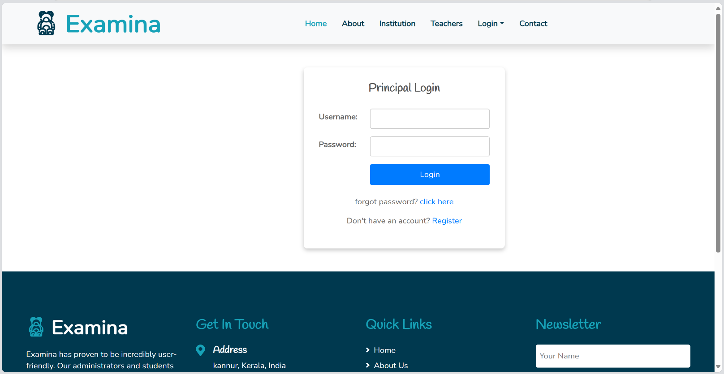

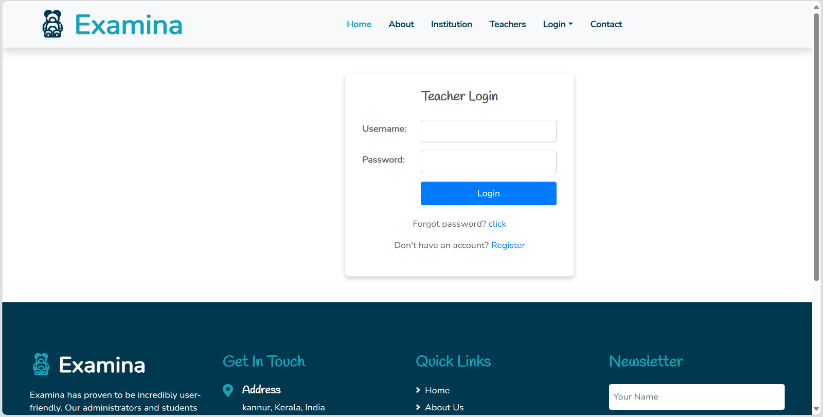
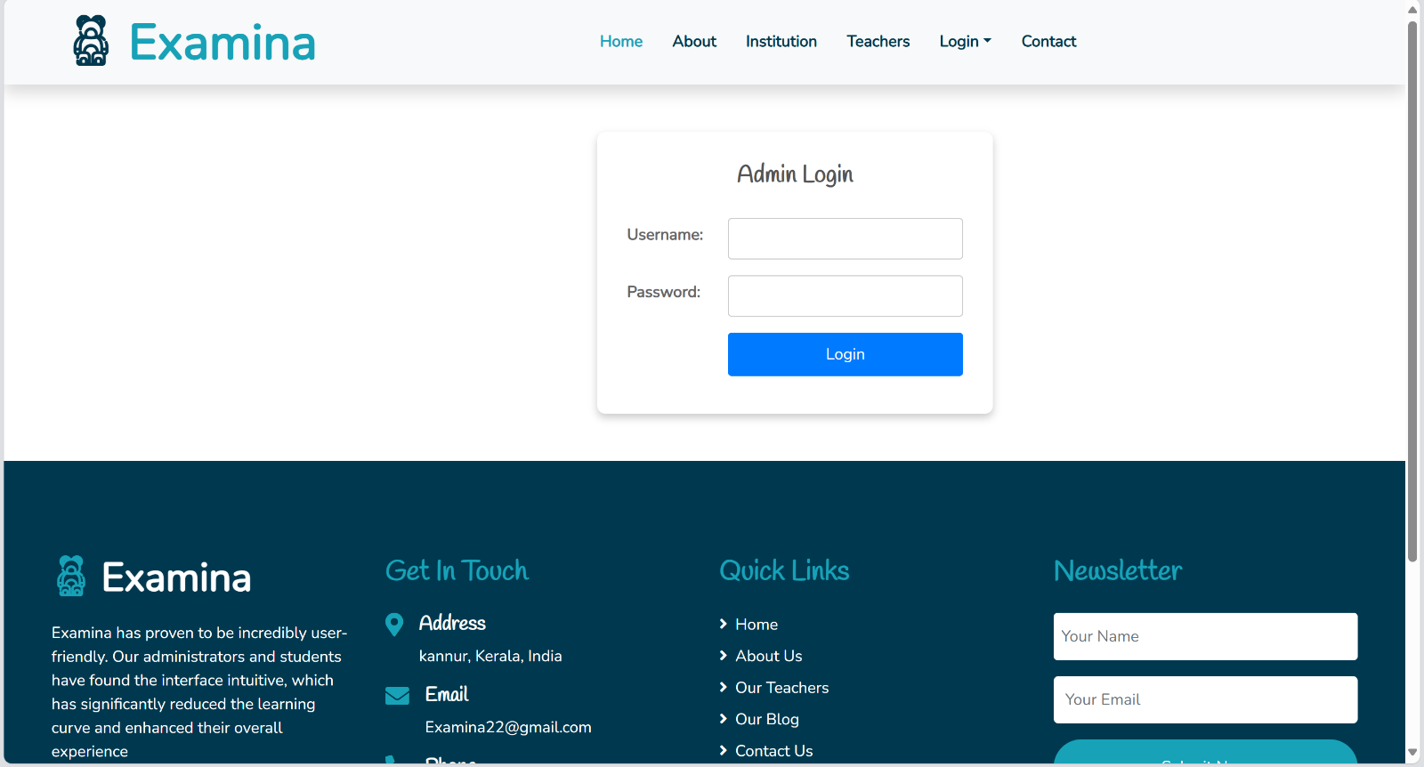
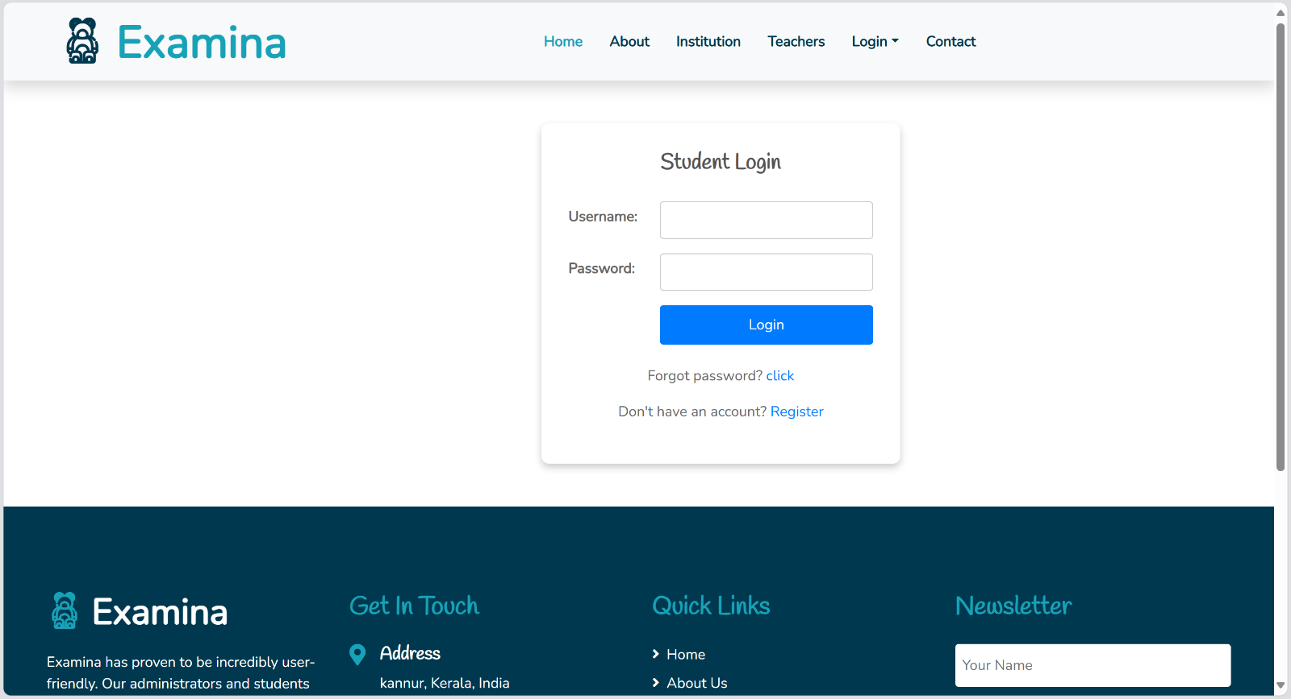

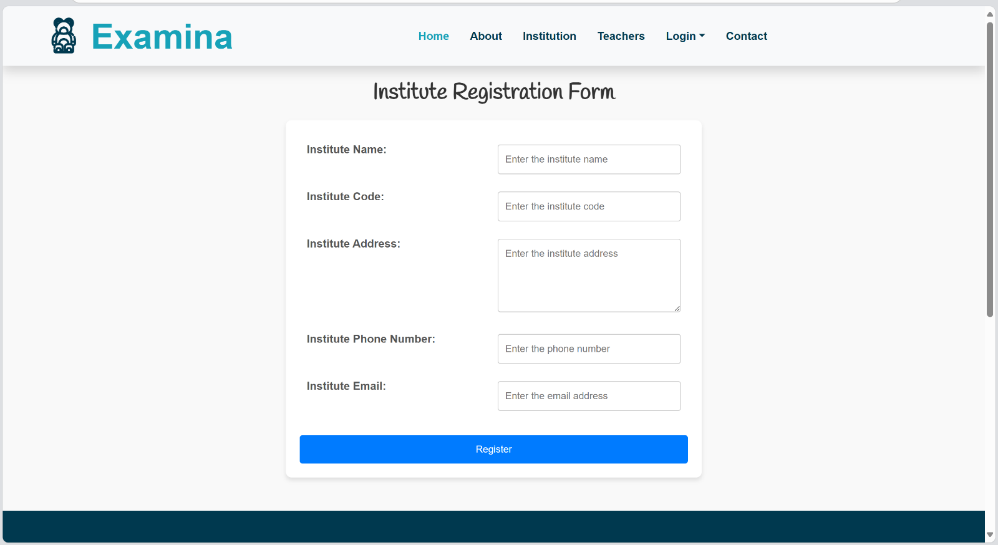
INSTITUTION REGISTRATION

CONTACTS PAGE
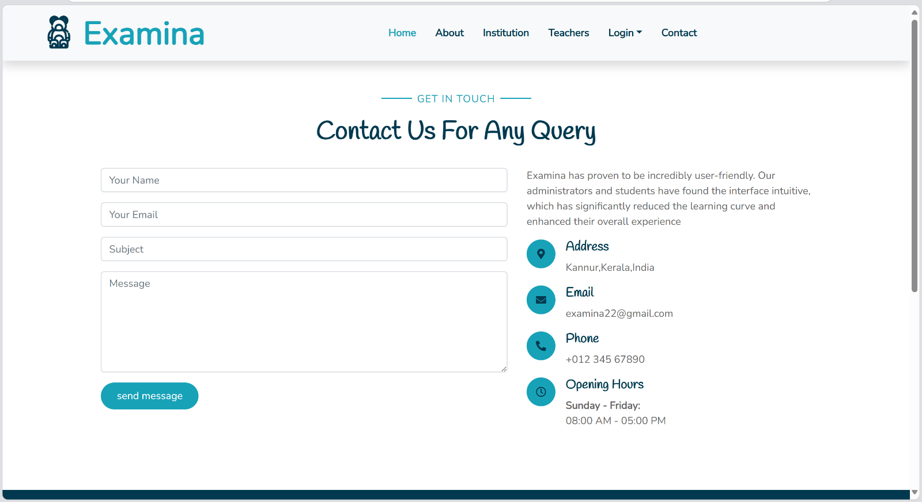
ADMIN HOME

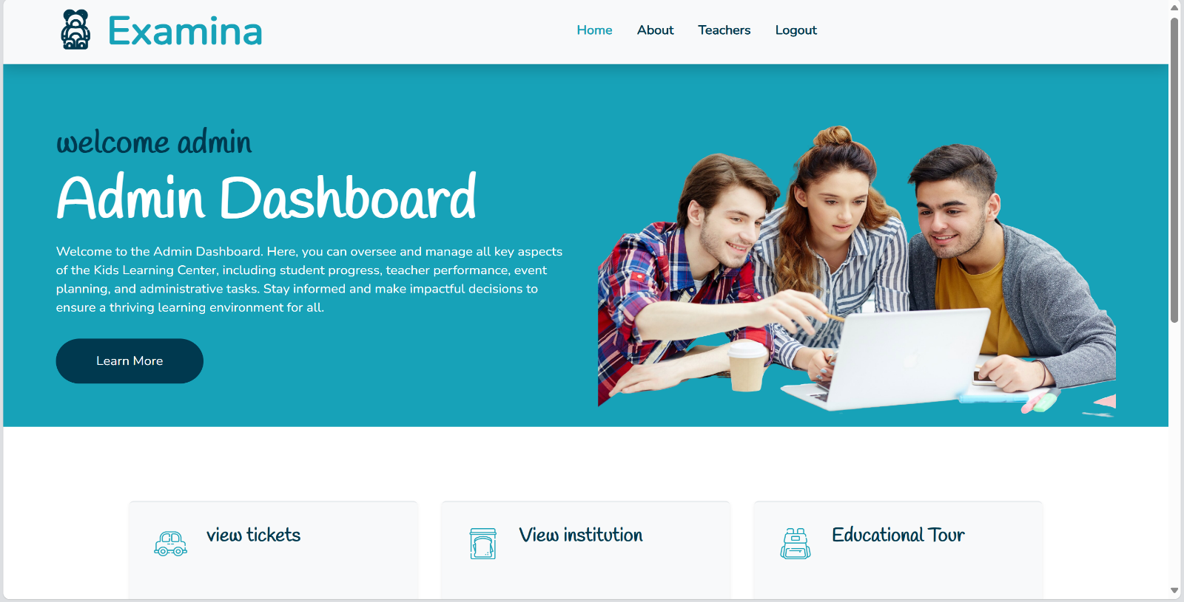

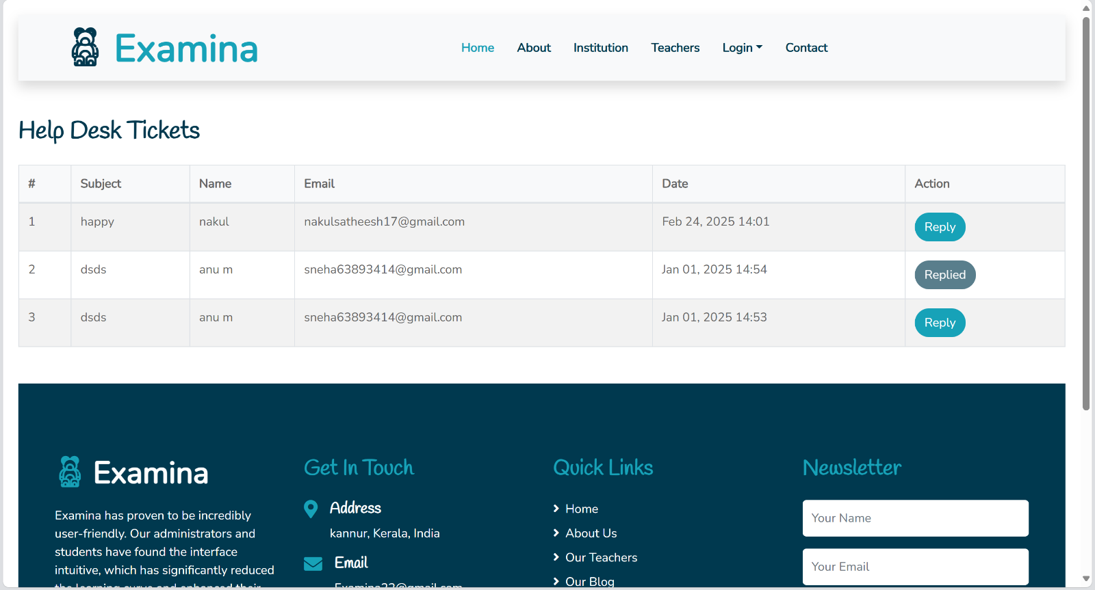
VIEW TICKETS
VIEW INSTITUTUION
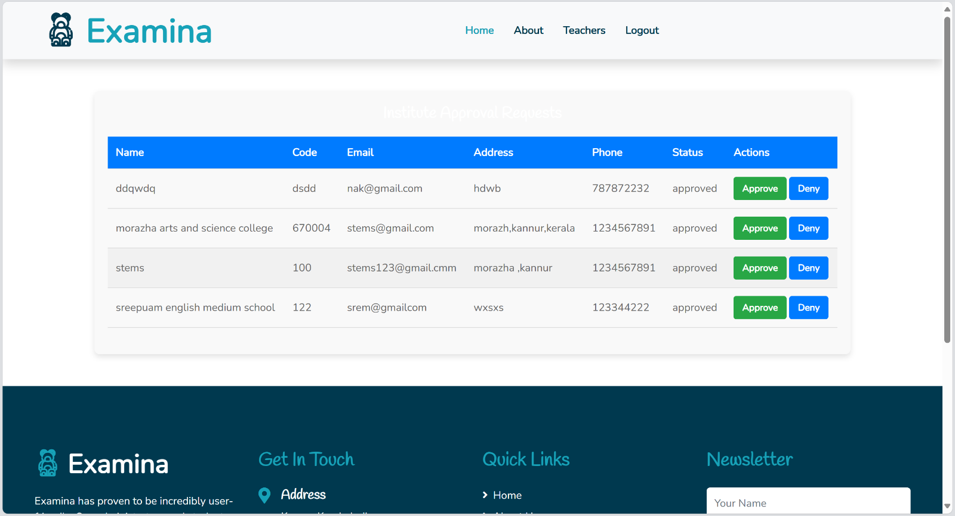
PRINCIPAL HOME

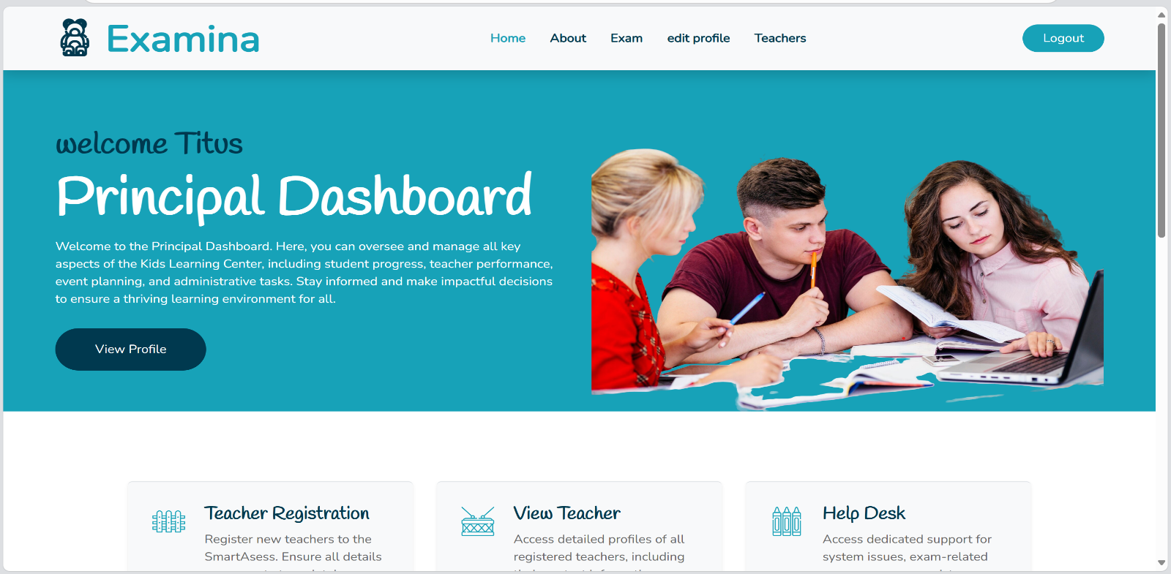

TEACHER REGISTRATION
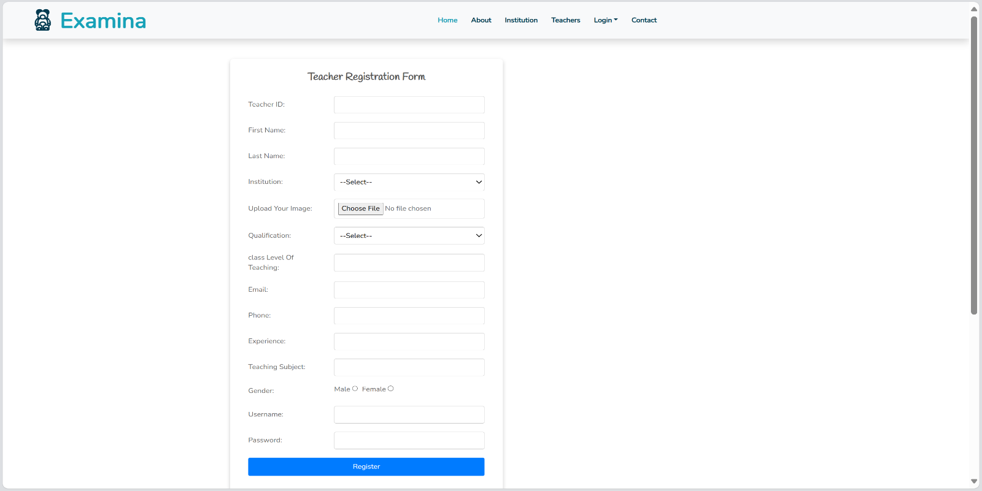
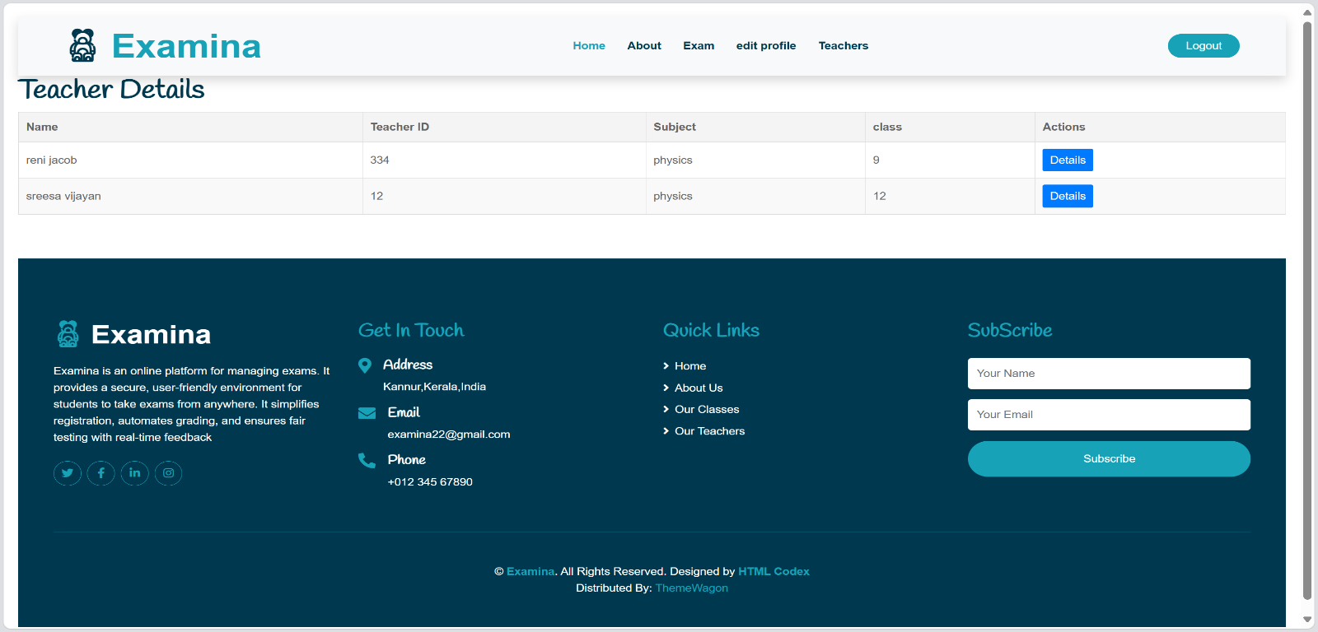
VIEW TEACHER

HELP DESK
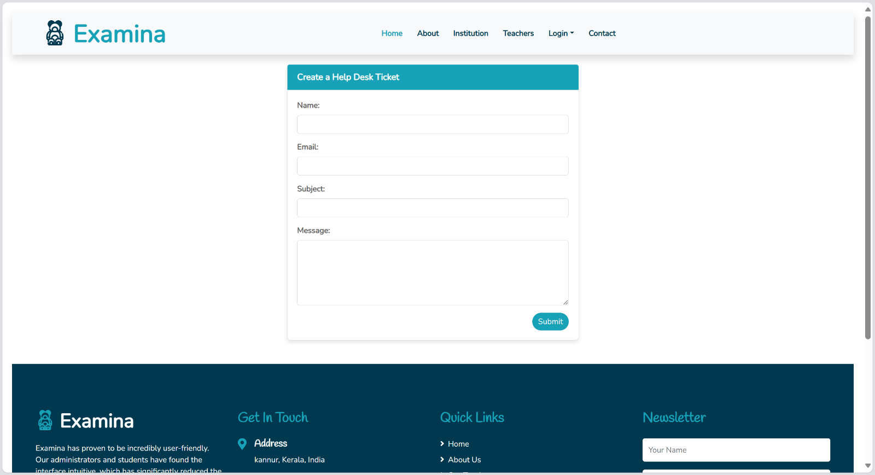

VIEW MARKS
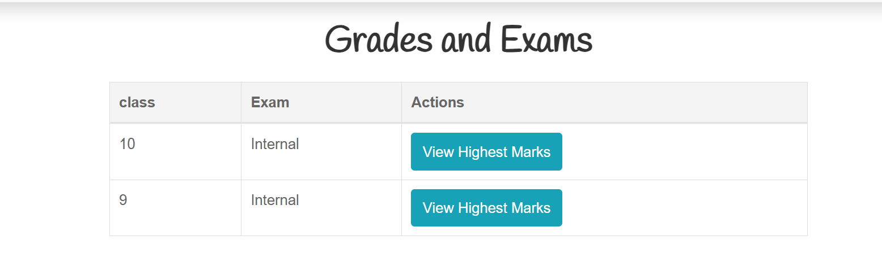

VIEW HIGHEST MARKS
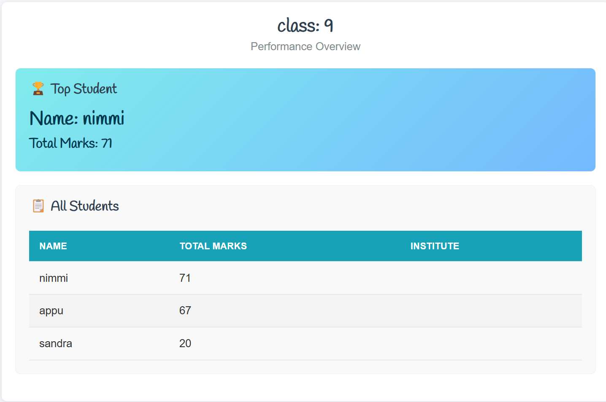
EDIT PROFILE

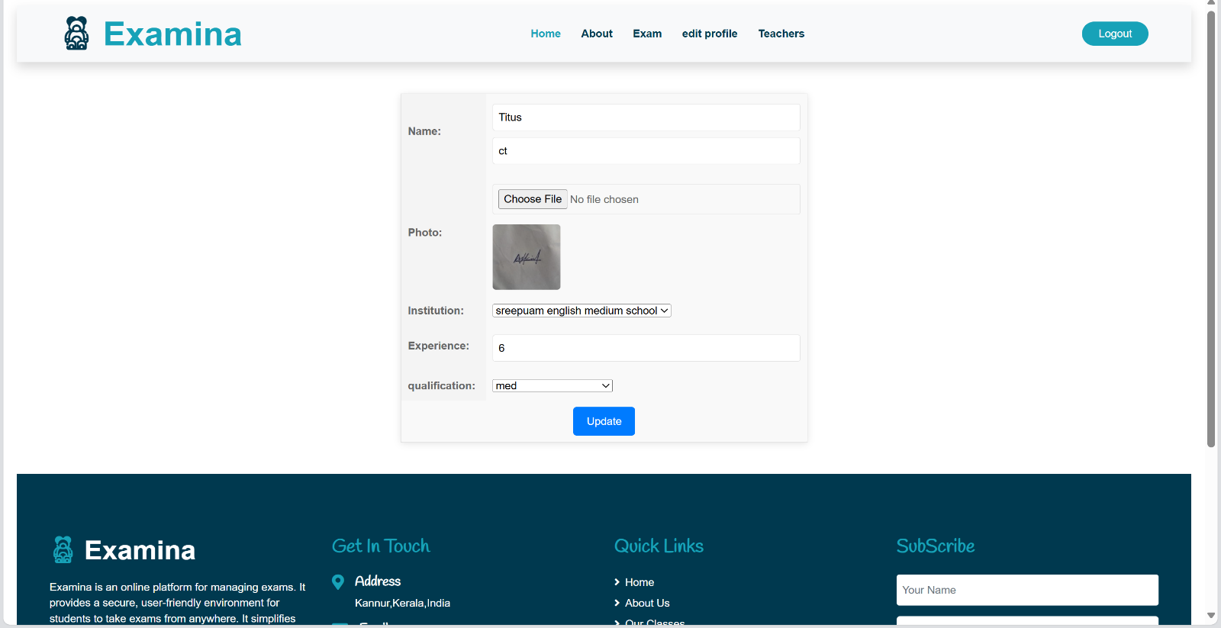

VIEW TEACHERS
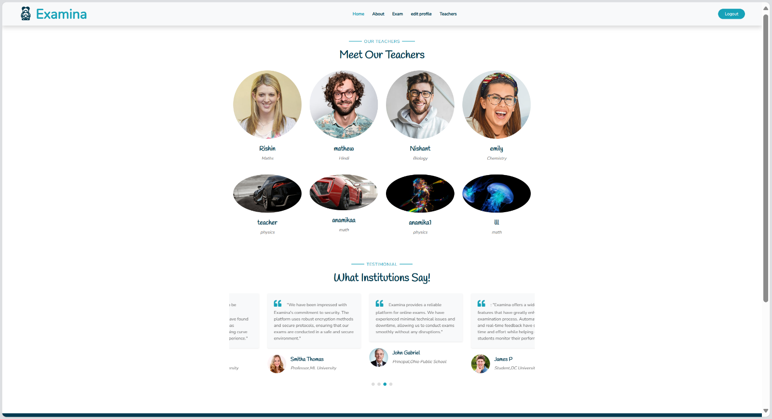
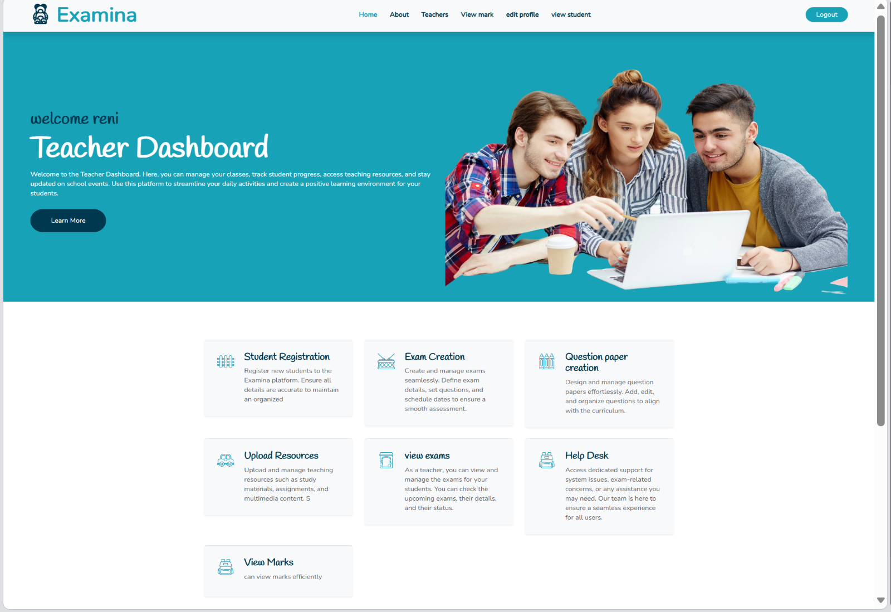
TEACHER HOME

VIEW MARKS
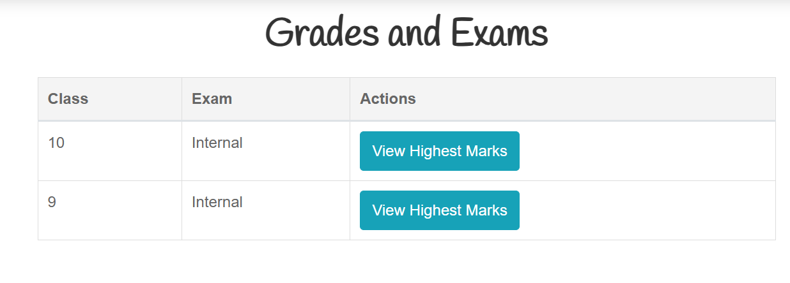
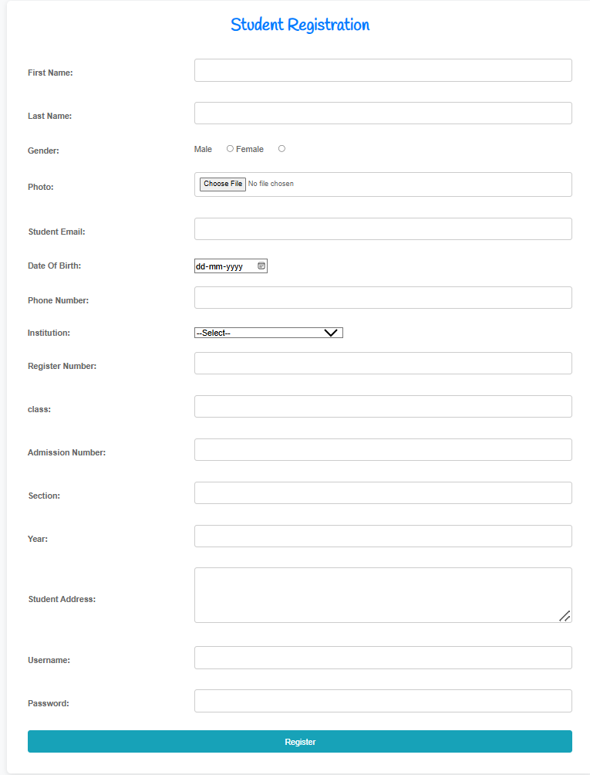
STUDENT REGISTRATION

EXAM CREATION

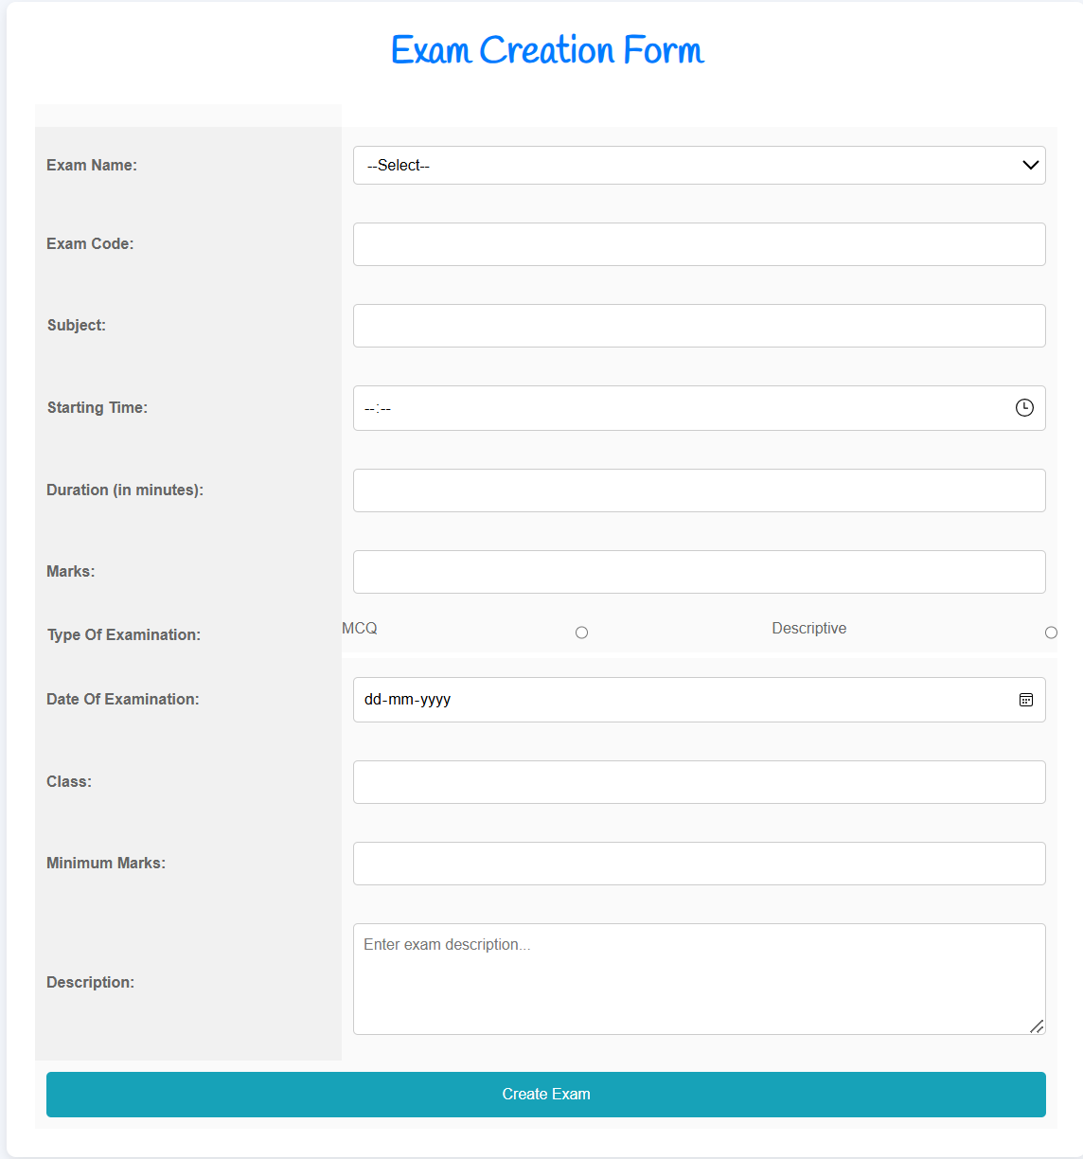

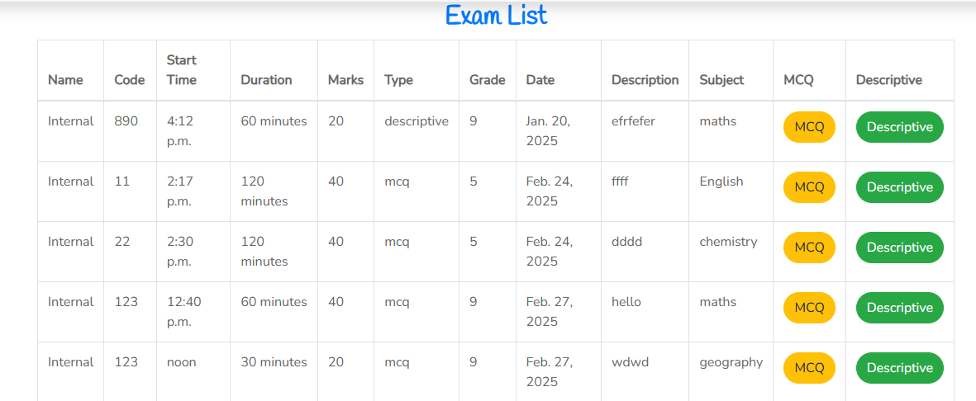
QUESTION PAPER CREATION

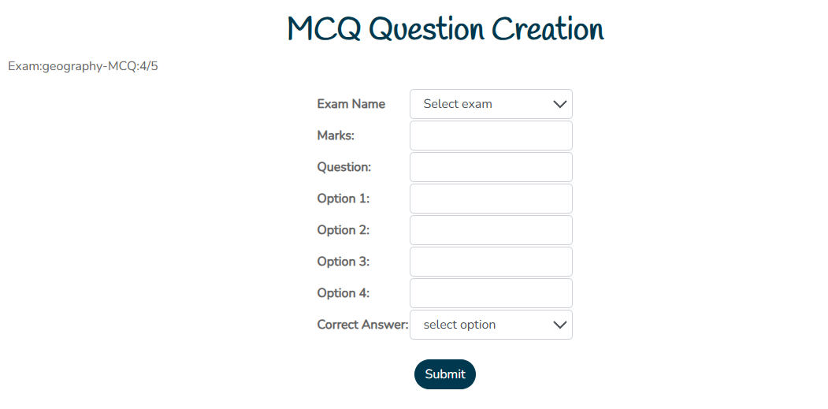
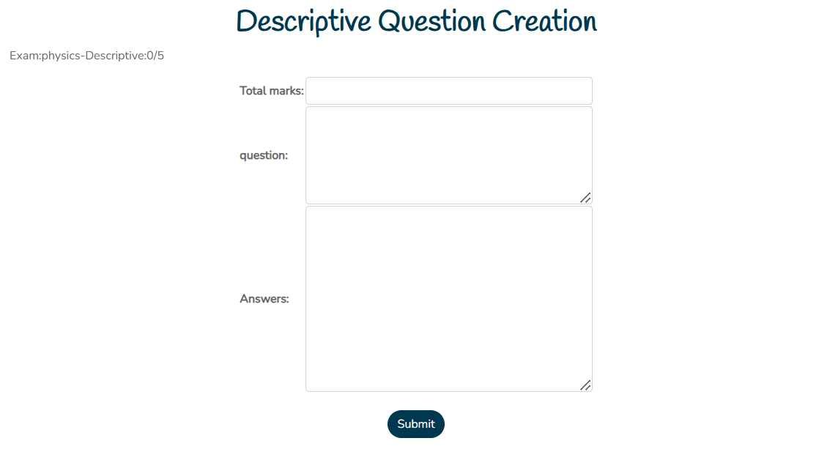
UPLOAD RESOURCES
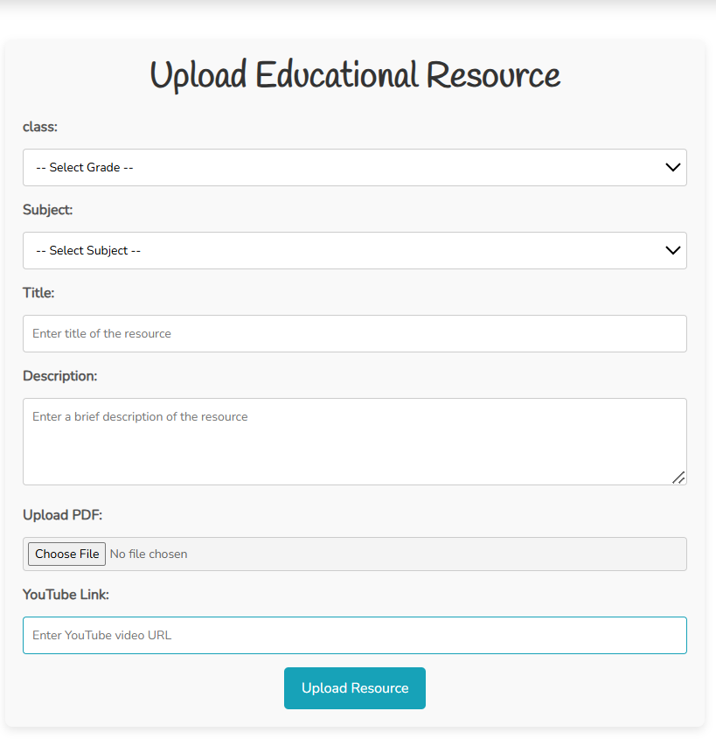

VIEW EXAMS

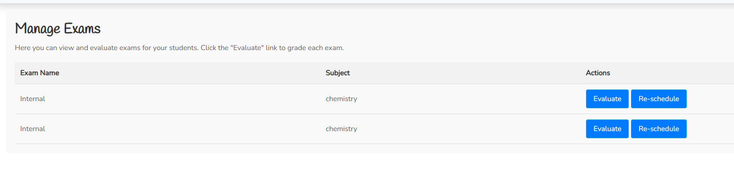
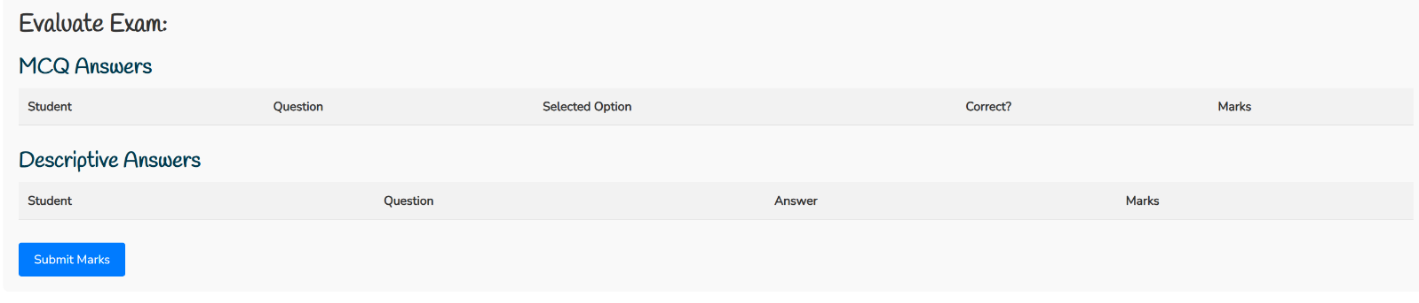
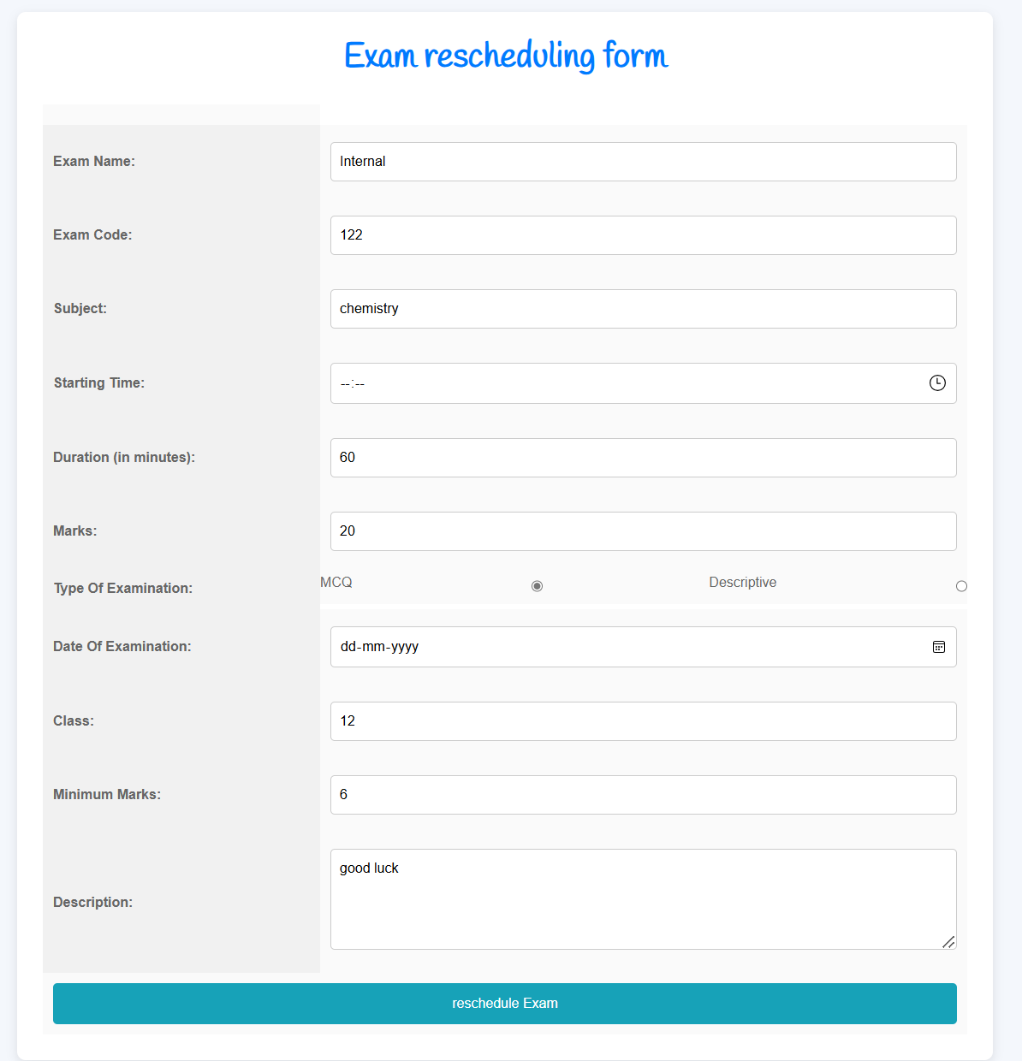
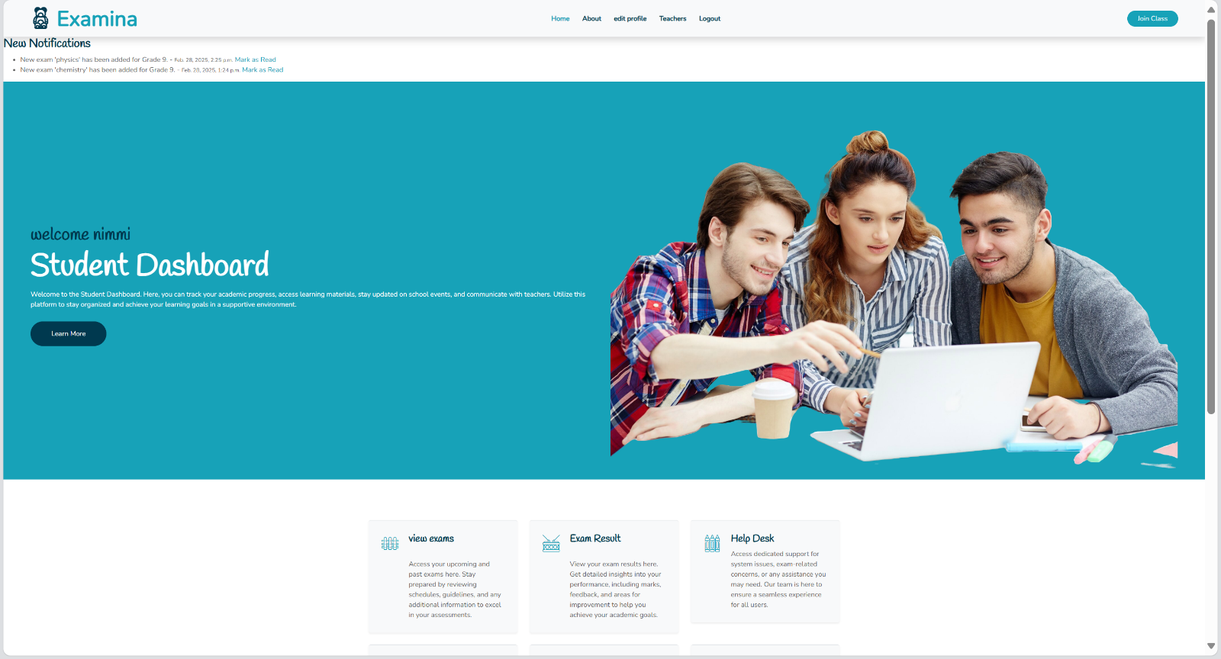
STUDENT HOME

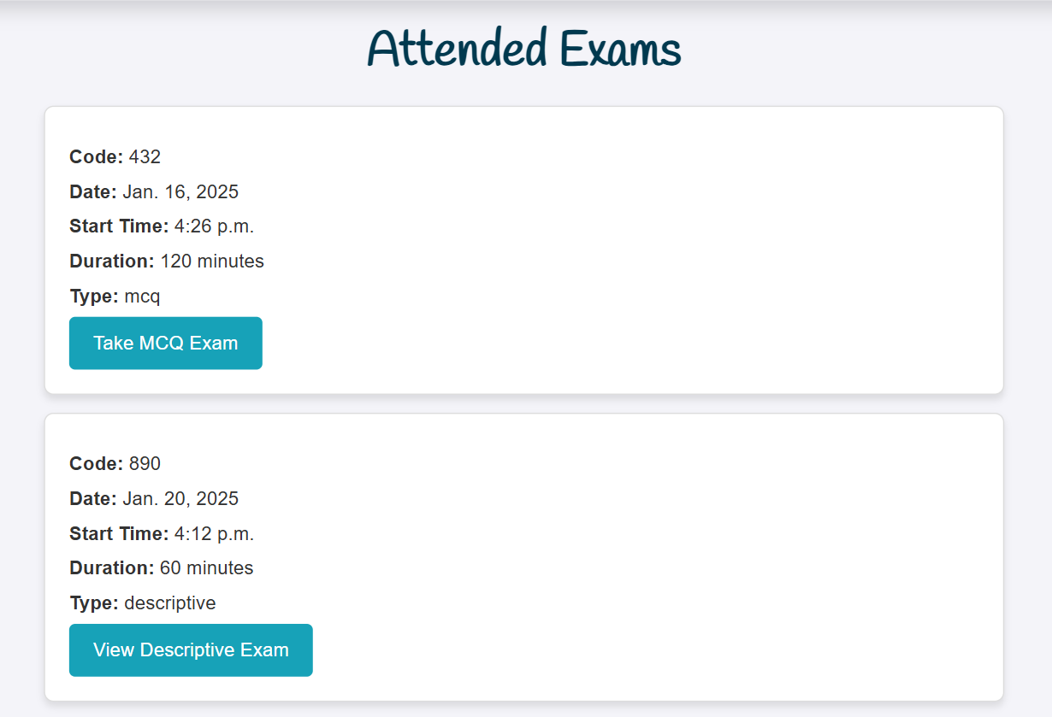
VIEW EXAMS
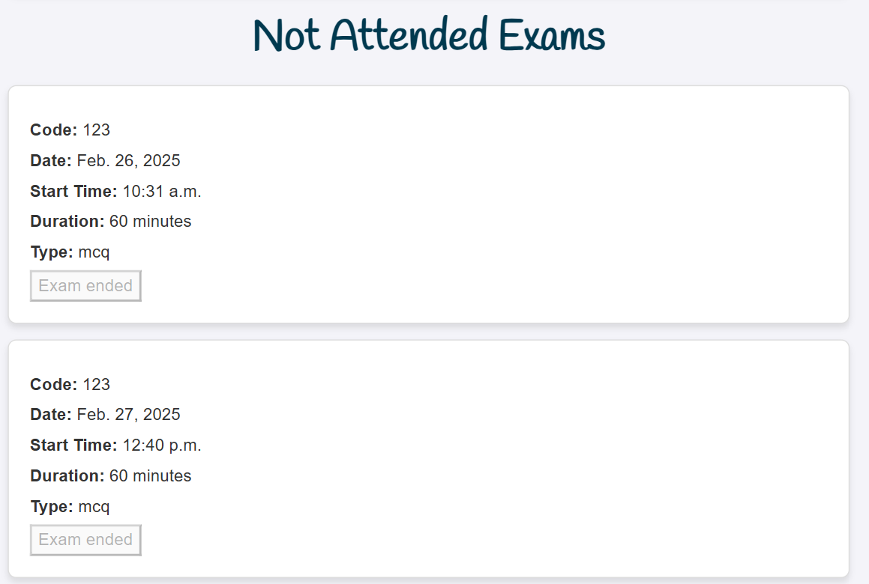

EXAM RESULT

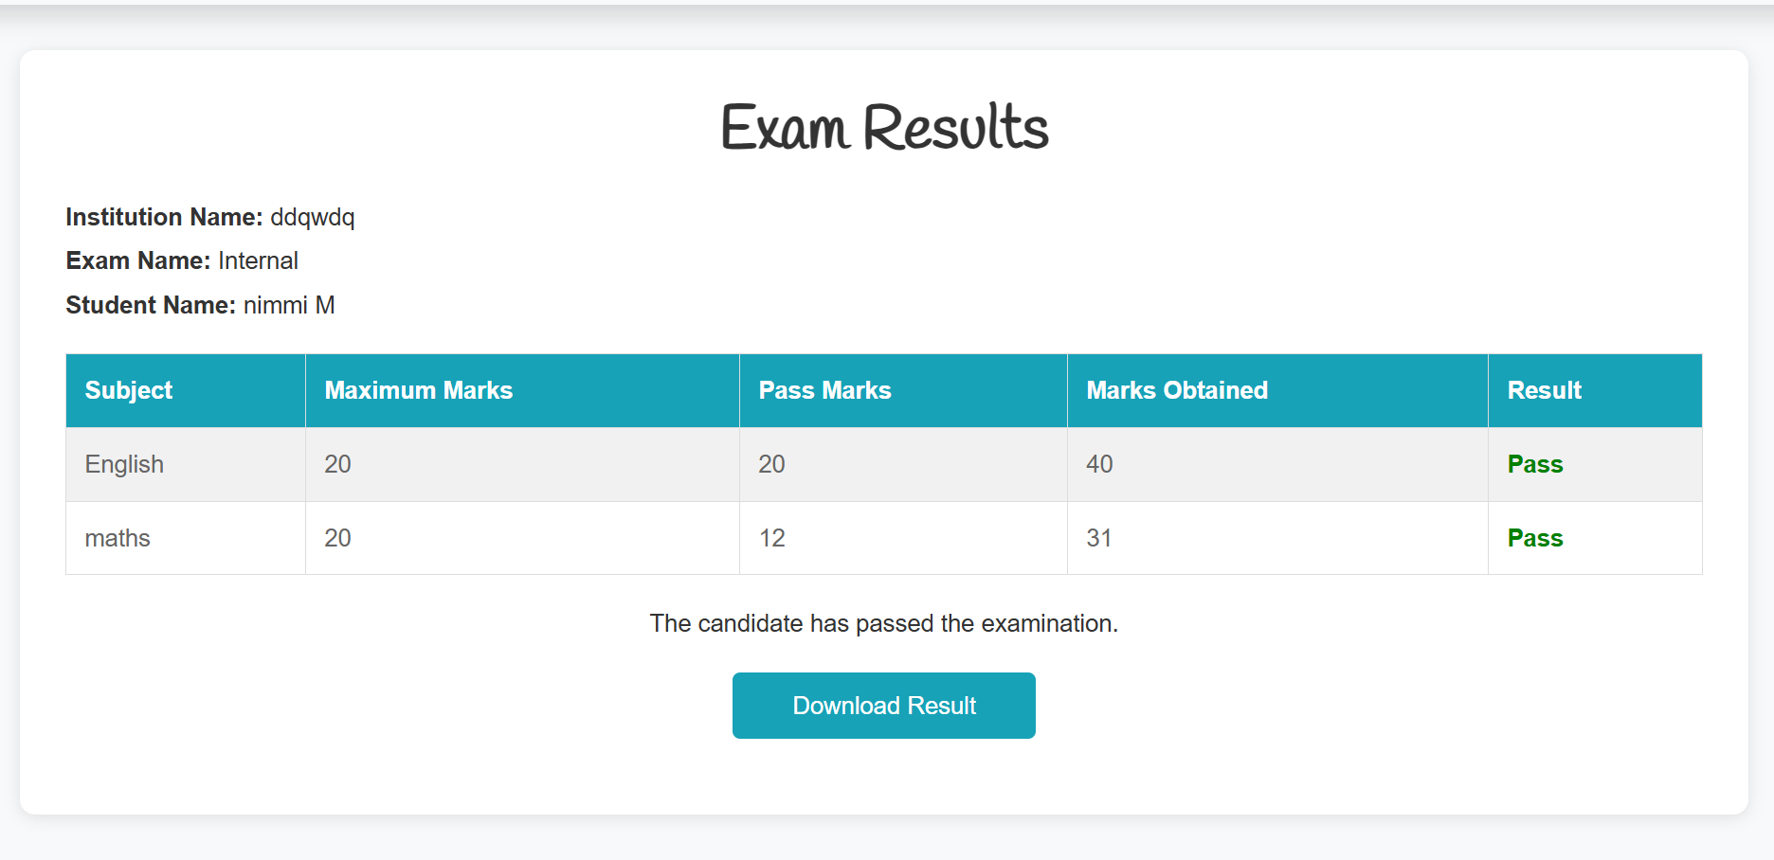

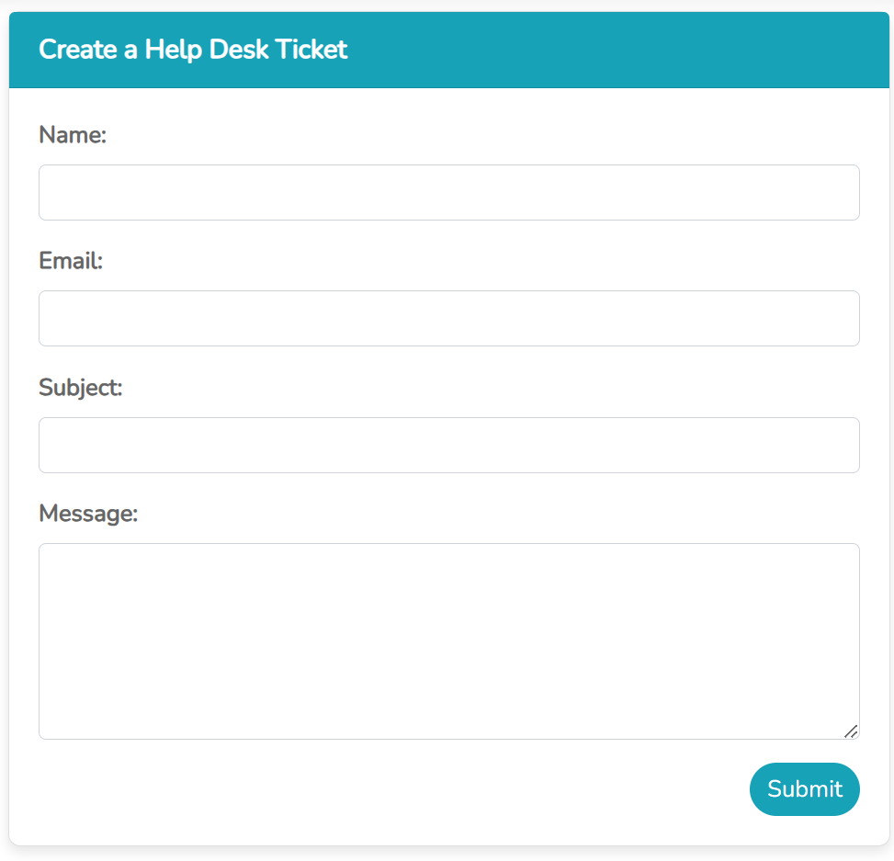
HELP DESK

CHANGE PASSWORD
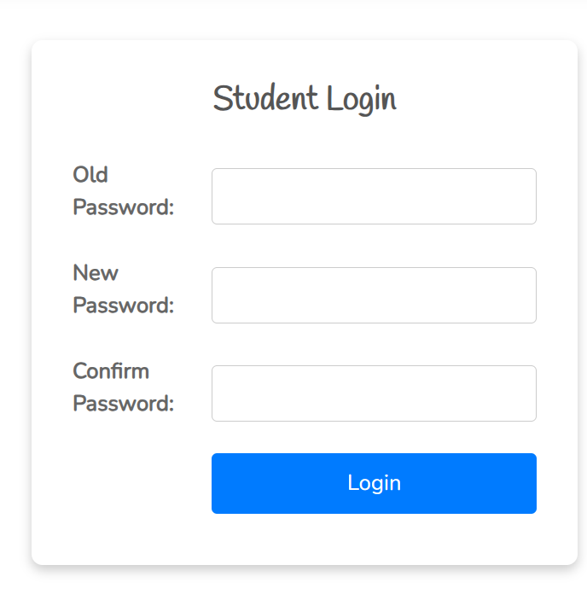

VIEW MARKS

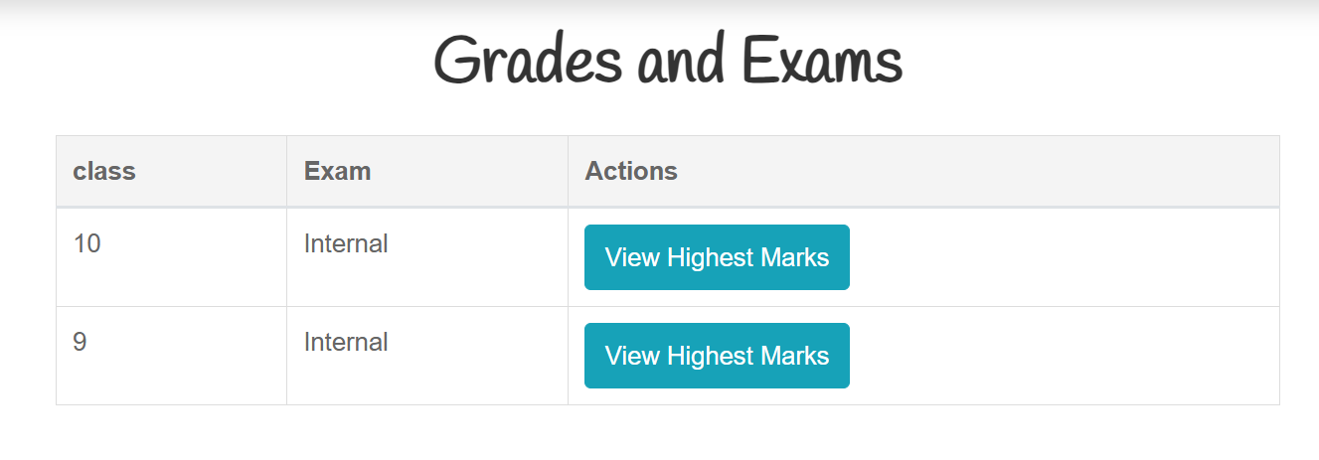

VIEW RESOURCES

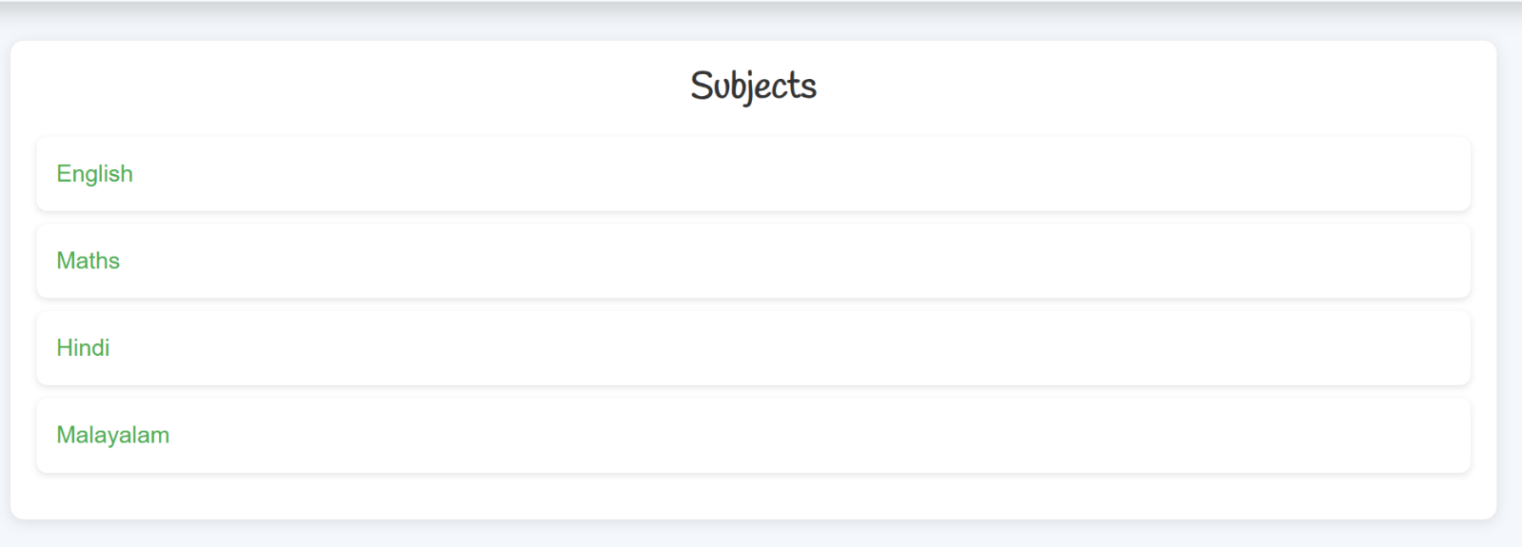

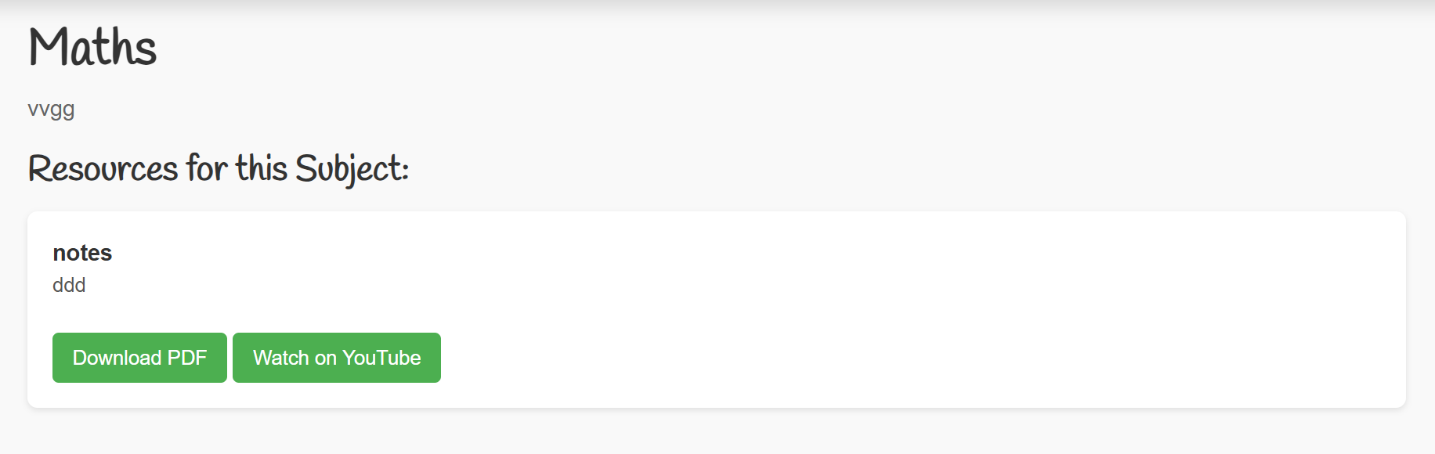

EDIT PROFILE

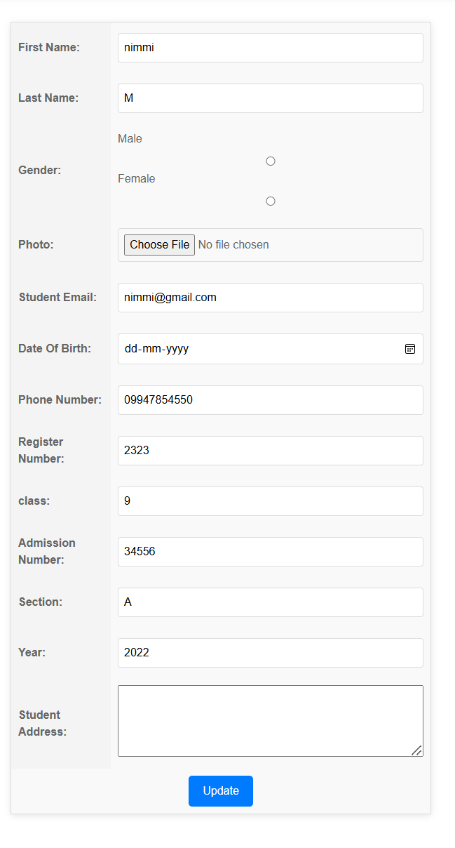

VIEW TEACHERS
